Assignment 1

1. Complete the VIA Strengths Finder. Save your Report. Analyze your report and reflect on it. What are your TOP 5 STRENGTHS? Do you agree? Disagree? Why? Do you feel you have strengths that did NOT rise to the TOP (e.g., Are these things you are currently working on strengthening, have been told they are strong areas for you, etc.?) Really reflect on what your report means TO YOU, and how you can use this information both RIGHT now, and in the future.

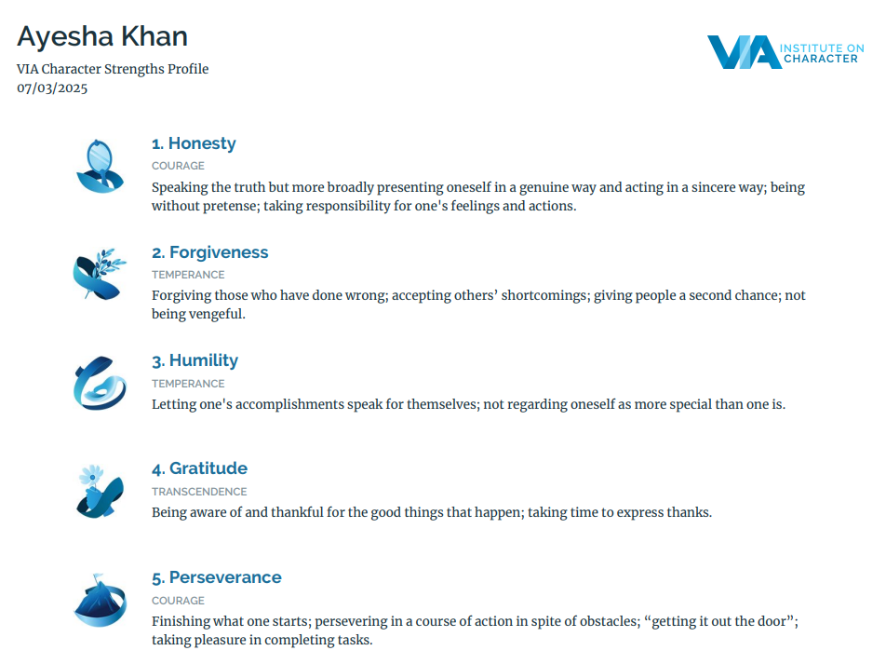

Surprisingly, I do mostly agree with my top 5 strengths. I would probably rank forgiveness higher than honesty though, simply because I tend to forgive easily and frequently, if the person is genuine in their apology. I have kindness at number 7 and I would switch that out for perseverance at number 5. I do see a task to its completion but I tend to get overwhelmed if there are challenges and obstacles in the way. I feel like these questions are very “Yes” or “No”, which kind of makes it hard to give my true answer. Even the neutral options don’t really help. For example, some of the questions talked about whether I let my emotions play a role in my decisions or I use logic. For me, it depends on the situation so it can be either one or the other. Just selecting “neutral” doesn’t really convey that. I am an emotional person, so I ended up going with that option for those questions. However, I do tend to use logic pretty frequently as well. Judgement is at 12 for me and I feel like it should be at 7. Another option that isn’t on this list is “Welcoming/Accepting”. I’ve been told I’m that and I agree with it as well. I wouldn’t exactly put that under “Fairness” because it’s slightly different. This report shows that I should certainly try to polish up the current strengths I have and work on those that are weaker but hold importance for me. Working on my weaknesses is a slow process but it’s certainly something I’ll continue to work on as of right now and in the future.

2. Complete (at least) one of the following personality inventories: Myers-Briggs type or Enneagram. Save your report. Analyze your report and reflect on it. Do you agree? Disagree? Why? Do you feel your results capture the essence of your true self / authentic self / true personality (e.g., as those closest to you know you best)? Really reflect on what your reports mean TO YOU, and how you can use this information both RIGHT now, and in the future.

I did the Myers-Briggs type Personality Test and this was the result:

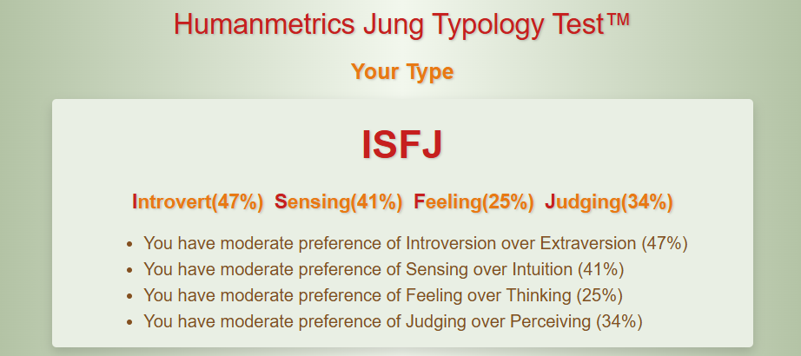

I’ve actually taken this test a couple times before and the result has stayed consistent over the years, which is interesting. I definitely agree with my type being ISFJ. I do have a “moderate” preference for introversion over extraversion. While I prefer having time to myself mostly, I also need to be around people and be surrounded by noise on a day-to-day basis. Although the “people” mostly consist of my siblings, parents, grandparents or cousins. I’m not one who requires or even wants to really be a part of social events and outings. I agree with a preference for sensing over intuition. I’m not really an abstract thinker and I prefer focusing on what I can tangibly observe with my senses. I find this ironic, considering I’m religious and that is an abstract concept. I do like how this test states I have a “moderate” preference of feelings over thinking. The questions still had the same issue as the VIA Strengths Finder test but I do lean slightly more towards feelings, so stating it as a “moderate” is something I can agree with. I’m very organized and prefer planning things in advance, so I agree that I have a preference for Judging over perceiving. I’m not rigid though and can definitely be flexible in certain situations. This test does capture my authentic self pretty well. If I were to ask my family to guess my MBTI type, it would be ISFJ. These kinds of tests help us reflect on our strengths and weaknesses and how we approach certain situations and relationships.

3. Complete BOTH the Leadership and Management style quizzes. Save your reports. Analyze your reports. What is your Leadership style? Do you agree? Disagree? Why? What is your Management style? Do you agree? Disagree? Why? Do your Management and Leadership styles “agree” with each other? Why or why not? What is the difference between your Leadership and Management Style? Really reflect on what your reports mean TO YOU, and how you can use this information both RIGHT now, and in the future.

Leadership Style Results

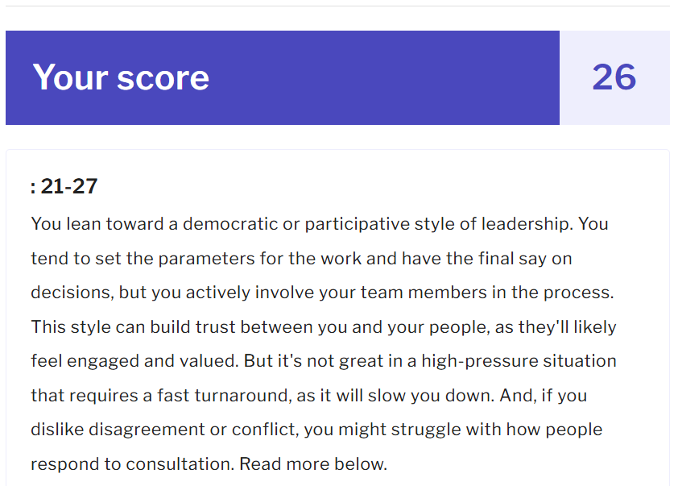

It was kind of hard to provide answers for both of these tests because I’ve never truly been in a management type position and I have very little experience as a leader. Hence, it was difficult to gauge whether my answers were those I would ideally like to do or those that I would actually do in those positions. But from the authoritarian, democratic, and delegating leadership types, I would definitely fall under democratic, which makes me think that I answered the questions well. I am not good in high pressure situations. I want to hear everyone’s opinion and ideas before deciding on something because I truly feel like I wouldn’t be confident in making decisions just based on what I believe. I want to value my employees and build trust among us. Of course, the downside to this is that employees can have differing opinions and navigating that would require certain skills I don’t believe I'm well-equipped with currently.

Management Style Results

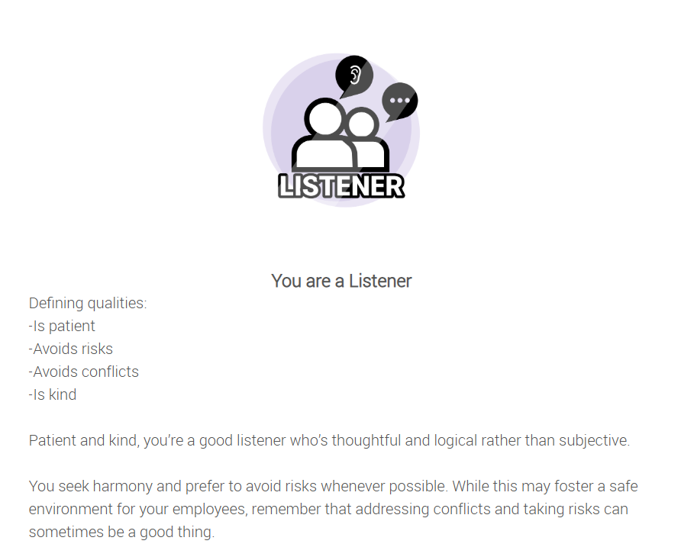

I agree with the results of the Management type test. I’ve gotten better at handling conflicts but if I was in a management position, I would definitely struggle with addressing conflicts and taking risks. I’m more cautious and would probably only go forward with something if there is minimal to no risk involved. This is an area I need to work on, regardless of whether or not I end up becoming a manager. I want to be able to work through and address the problems I’m facing with people rather than avoiding it and hoping it rights itself.

Both the leader and management types are similar in that they avoid risks and both types aren’t really good for “high pressure” situations. Listening to my employees and building trust amongst us, while getting their input before making a decision is something that is similar with both.

Discuss and reflect on the following

Q1. What is the difference between Leadership and Management, in general?

When I think of leadership, I tend to see it as a more informal position and management a more formal position. They both are very important and can often be used interchangeably but I would attach the word “operations” with management and the word “vision” with leadership. I often think back to my Food Service SEL, where I watched the Food Service Director manage the day-to-day situations that would come up. He would also plan more short term, with a focus on improving whatever problem he’d encounter for the day. For leadership, I think of it as more like a long-term goal or vision that one works towards and I feel like it’s a more engaging position in terms of interaction with people.

Q2. What types of leadership do you experience in your life? What type of leadership do you most LIKE? Why?

I haven’t had much of an experience in this area unfortunately. I know I was the Headgirl in school and responsible for hearing the problems of the student body, but I didn’t do a whole lot in terms of making reforms and changes. I like the democratic leadership style the most because of how engaging it is. I don’t want to be in the position where I have responsibility for my employees but I hardly keep any in-person contact with them. I also don’t want to be imposing and micromanaging everything because that’s something that tends to bother me a lot, if I was in the position of an employee. I highly value the input of others and I need more than my own perspective to reach a decision. This does have the downside of me not being good at handling high pressure situations, which is something I will certainly need to work on.

Q3. How do we select leaders, or how do leaders emerge? Give an example from your life or workplace.

I feel as if leaders emerge either directly by someone working to attain that position or indirectly by someone’s actions, which influences the people around them to select/elect them for a particular position. Sometimes they naturally emerge like in a group project, where one person initially starts the communication, makes the group chat, and outlines the project. In that situation, they are naturally chosen to be the leader, without it being explicitly stated. That’s something I’ve experienced and seen too. I guess me being elected by the student body to be the Headgirl for the school is an example of how leaders are elected. Another example is of my senior at school, who wanted to be the head of the debate club, so she had put in a request for that, which was accepted.

Q4. What types of MANAGEMENT do you/have you experienced in your life? What type of management do you most LIKE? Why

I have not held any management positions but I’ve interned with the Food Service Director of King’s and he was a mix of most of the styles, the prominent ones being planner, problem-solver and coach. I honestly like the listener and problem-solver of the management styles. I got the Listener style and that’s something I agree with because I want to listen to people’s problems and build trust amongst my employees. Of course, I would also want them to trust me. I would certainly not fall under problem-solving, innovator, coaching and free spirit. I suppose that’s why problem-solving is a kind of style I really like. I want to be more adept in that area. That aside, I can also fall under planner because that’s something I like to do. I’m very organized and plan ahead for all sorts of upcoming events or other situations.

References

1. VIA Institute on Character. VIA character strengths survey & character profile reports. viacharacter.org. Published 2025. https://www.viacharacter.org/

2. Humanmetrics Inc. Personality test based on Jung and Briggs Myers typology. www.humanmetrics.com. https://www.humanmetrics.com/personality

3. MacLeod C. What’s your leadership style? MindTools. Published 2024. https://www.mindtools.com/azr30oh/whats-your-leadership-style

4. Interactive Calculators & Quizzes. predictiveindex.outgrow.us. https://predictiveindex.outgrow.us/manager-style-quiz

