Ayesha Khan
ND 616 – Food Systems or Service Supervised Experiential Learning
Competency 3.3
Applies principles of food safety and sanitation to the storage, production and service of food
Competency 5.5
Develops and leads implementation of risk management strategies and programs (D)
Activity
These competencies were met by working with Jeff Fields in the Allergen Kitchen at King’s College and are discussed in the reflection below.
Reflection
The Allergen Kitchen was a very interesting experience. I’ve done a couple of courses on Food Safety and Management, which talk about holding foods at the correct temperature and keeping them out of the Temperature Danger Zone to avoid food spoilage. However, actually getting to experience it first-hand is a completely different experience, at least in my case. I realize that I tend to retain information better if I’m actually observing it.
I worked with Jeff to check the temperature of the Hawaiian chicken recipe he was making for lunch. The Temperature Danger Zone for foods is between 40 ºF and 140 ºF. In this range of temperatures, food is highly likely to spoil and cause foodborne illness due to bacterial multiplication.¹ Therefore, it’s important that thermometers are used to check the temperature of foods during cooking and serving. This is done by inserting the thermometer in the thickest part of the meat.
When we initially check the temperature of the chicken, it was at 145 ºF. Jeff explained that it’s important for the chicken to be at around 165 ºF when cooking. When we checked it again after a few minutes, the chicken on the outer side of the oven was around that temperature but the chicken pieces on the back side of the oven were still around 150 ºF. This is why it’s necessary to check the temperature of a few different chicken pieces as only checking one doesn’t guarantee that the rest are the same temperature, due to difference in heat distribution when baking/cooking.
It was fun listening to Jeff talk about his experience working in this area. He talked about how he avoids the 9 main allergens, namely peanuts, milk, tree nuts, wheat, sesame, fish, eggs, shellfish, and soy and how it’s important that no one else comes through his kitchen area due to chances of cross-contamination. He mentioned that last year, he would make meals for around 3-4 students who had different allergies and would also make their meals over the weekend, when the Allergen Kitchen is usually closed, which they could come collect at any time.
I also got to see the purple-coded kitchen utensils and plates he uses in the Allergen Kitchen, which was fascinating. One thing I really liked was the fact that the fresh chicken served at King’s is Halal. As someone who can only eat that kind of chicken abroad, it was a very pleasant surprise.

References
1. USDA. “Danger Zone” (40 °F - 140 °F) | Food Safety and Inspection Service. www.fsis.usda.gov. Published June 28, 2017. https://www.fsis.usda.gov/food-safety/safe-food-handling-and-preparation/food-safety-basics/danger-zone-40f-140f

Pictures can be viewed below
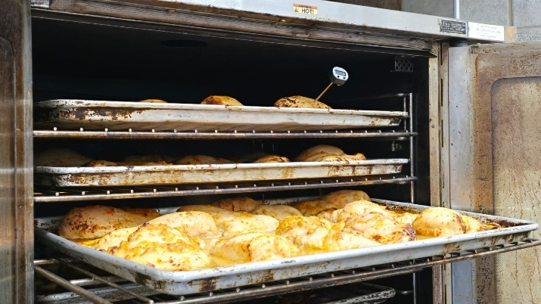 | 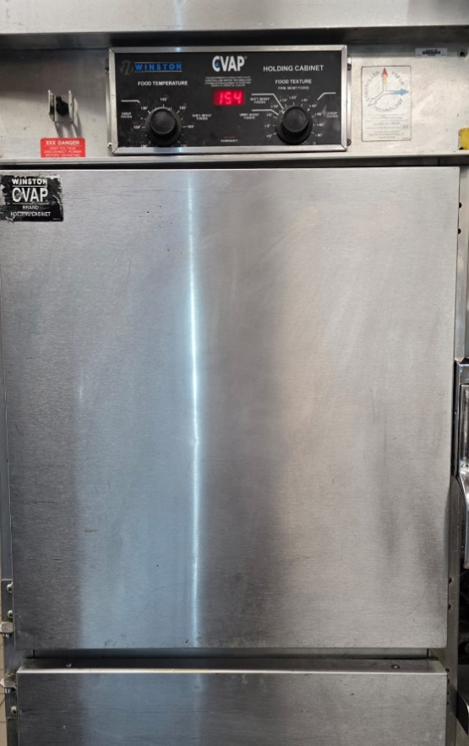
The picture on the left shows the thermometer being inserted in the chicken to check the temperature. The picture on the right is the warmer where food is held at the appropriate temperature before it is served (154 ºF)

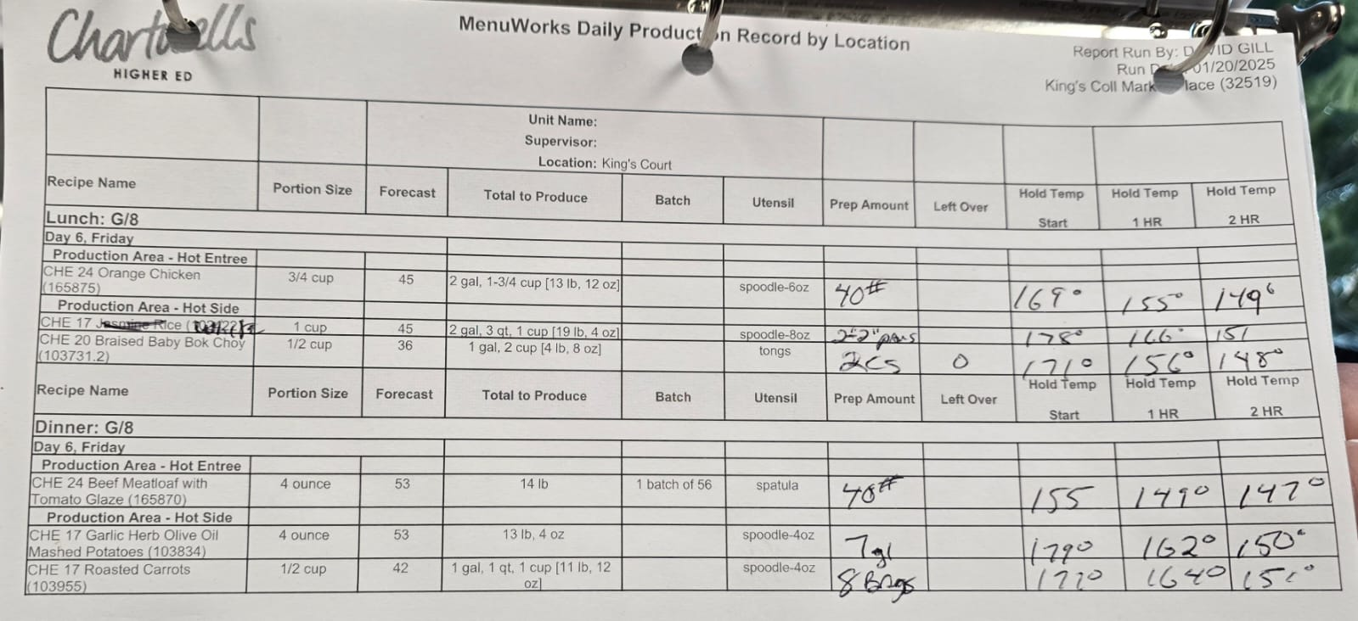

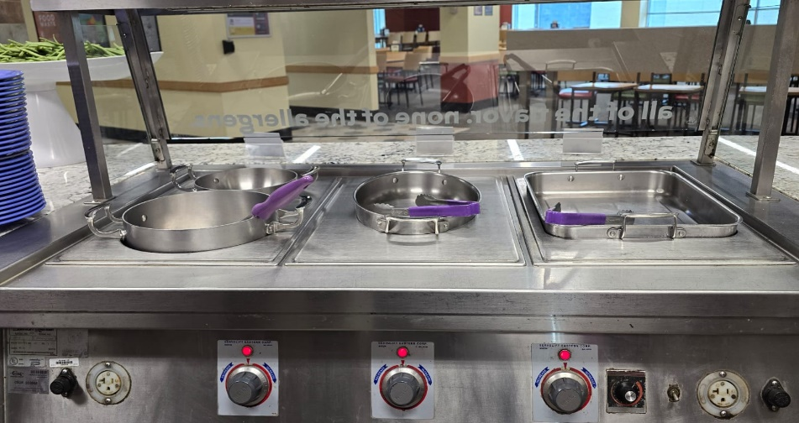

The picture above is a record of each meal; the produce, the prep amount, leftovers and the holding temperature that is checked every hour for two hours. The picture below is where the food is served. The purple-coded utensils and plates are to signify that they can only be used in the allergen-free kitchen.

