Ayesha Khan
ND 616 – Food Systems or Service Supervised Experiential Learning
Competency 4.2
Engages in legislative and regulatory activities that address community, population and global nutrition health and nutrition policy (D)
Activity
This competency was met by attending the Food Policy Council meeting of Buffalo and Erie County, held at Hayes Hall at the southern campus of University of Buffalo. My preceptor was one of the stakeholders at the meeting. I also read up on the Good Food NY Bill and the 1115 Waiver of NY. There was limited opportunity for me to do much else for this competency unfortunately.
Reflection
Attending a Food Policy meeting was more different than I expected. I didn’t understand much of anything they were discussing. I was able to follow along what updates, grants, and policies were being discussed because of the Agenda/Table of contents on one of the papers they handed out. However, the contents of those updates were confusing. After the meeting, I remember asking my preceptor how she was up to date on everything and could understand it. She mentioned that her first policy meeting was her being confused by everything as well, which was funny. Then she said that if you jump right into it and continue to attend these meetings, this stuff becomes easier to comprehend.
She was also one of the stakeholders in the meeting. She told me to read up on the Good Food NY Bill and the 1115 Waiver of NY to get an understanding of what grants, bills, and policies are, which I ended up doing. She also gave an overview of what this Bill and Waiver were about, so I wasn’t completely lost when reading up on them. I felt like I learned a lot but at the same time, I won’t have a long-term recollection of what I read, since it was quite a bit of information to absorb and wasn’t exactly within my sphere of interest, career-wise. It was interesting to see a different side to nutrition and health though! Food Policy is definitely not what I expected when I attended the meeting and I’m glad I was able to experience this.
Pictures can be viewed below

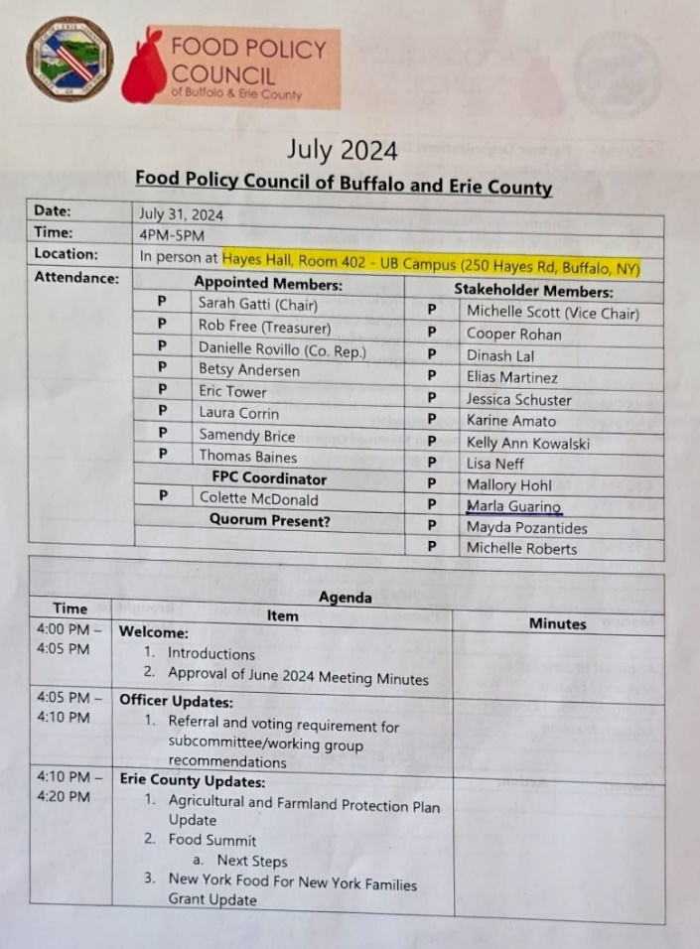 | 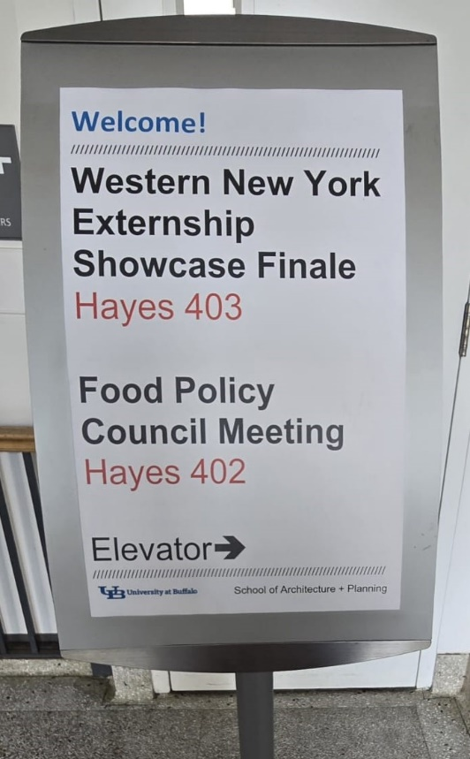
The picture on the left includes a list of people who were attending this Policy meeting and what was on the “Agenda” for the entirety of the meeting (this is only one side of the page). The photo on the right is a stand that tells which Hall number the Food Policy meeting will be taking place.

