Ayesha Khan
ND 616 – Food Systems or Service Supervised Experiential Learning
Competency 2.1
Applies a framework to assess, develop, implement and evaluate products, programs and services. (D)
Activity
This competency was met by taking part in the Heart Healthy Wellness Event at King’s College.
Reflection
It was fun being a part of this program. King’s Dining was in charge with making the wraps and fruit-infused drinks. I helped with bringing the wraps, drinks, and produce to the table and setting everything up. I was working with Nicole Barnabe, a Dietitian and Food Service Director at Scranton, as she had come down to the campus to take part in the program. I was a little hesitant at first when students came up to our table but Nicole told me that the people coming up to our table were probably just as hesitant as me, which was a very good way of looking at it. It was our job to put them at ease, which we did.
When the students and faculty came up to our table, we talked to them about the different ingredients in the wraps and how they are good for the heart. It was nice to see the positive feedback we got on the wraps, which were very good. We had oranges and bananas on the table as well and encouraged anyone who came up to our table to take them. It was interesting hearing how some of them use their produce at home. The tables around us were also selling produce, heart healthy seasonings and canned drinks and one table was giving lessons on hands-only CPR, which I thought was very intriguing.
After the event, I evaluated the success of the wellness program. Things could’ve been improved in a few areas. Firstly, I feel like having the calories and other nutrients on a template next to the wraps would’ve been better, as I had someone ask me about the calories. Secondly, it would’ve been nice if we had another kind of fruit-infused drink. Cucumber mint and lemon were the drink options we had. Using grapefruit, oranges or another citrus fruit would’ve been great for more variety. Lastly, our table should’ve been more aesthetic to fit the vibe of the event. A lot of tables had the red, pink and black aesthetic which looked incredibly nice and inviting.

Pictures can be viewed below
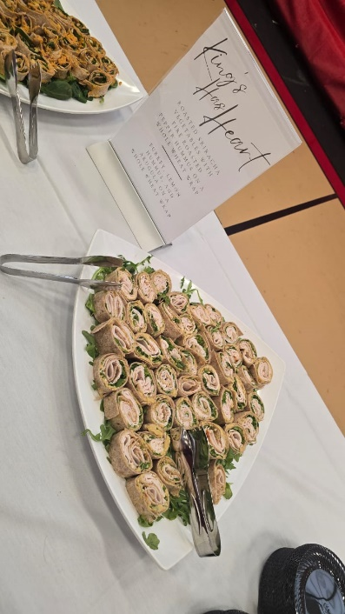  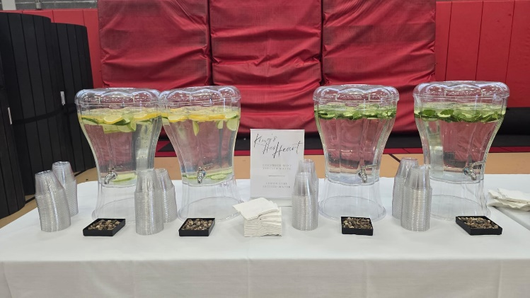 | 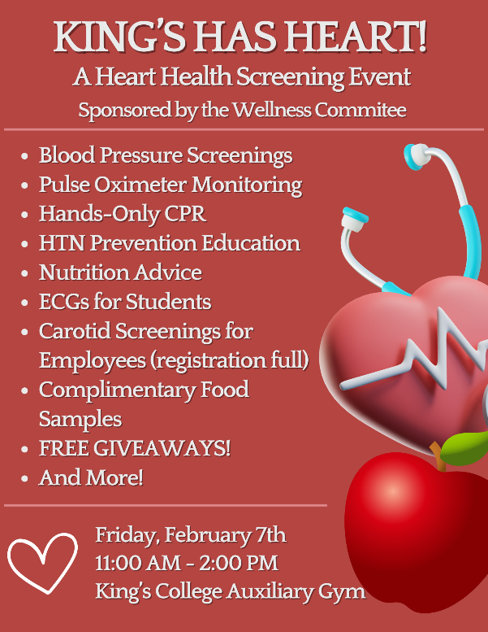
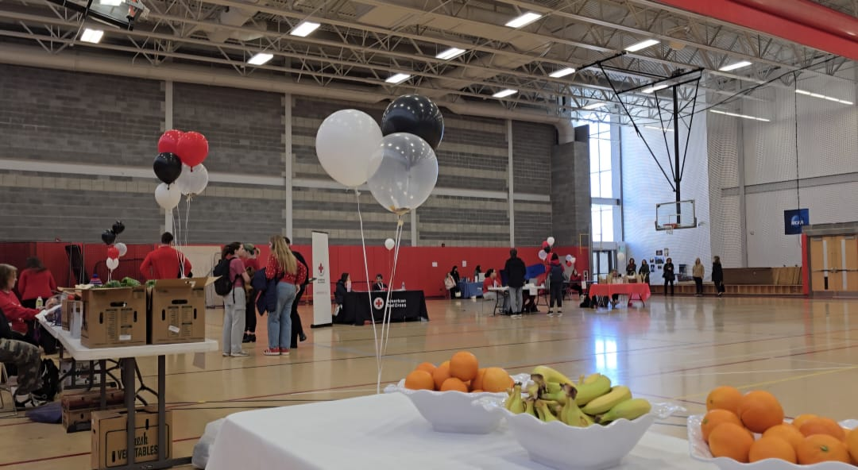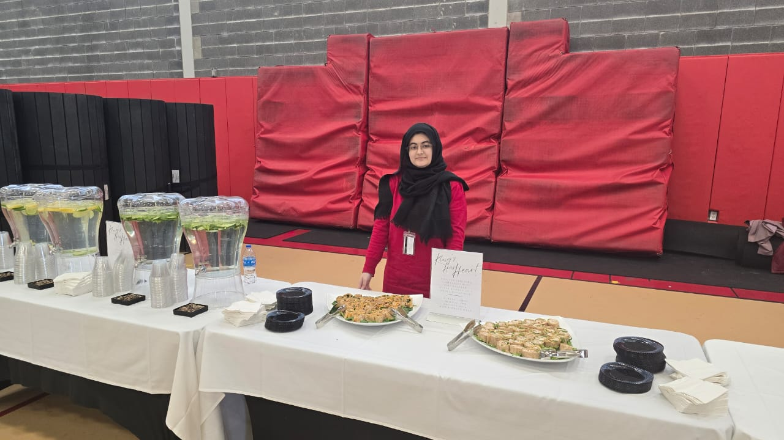

These pictures show the Wellness Event where we handed out free heart healthy food and beverages. When students and faculty came up to our table, we discussed what the ingredients were in each wrap and how they’re good for the heart.

