Ayesha Khan
ND 615- Community Nutrition Supervised Experiential Learning
08/19/24

Competency 4.1
Utilizes program planning steps to develop, implement, monitor and evaluate community and population programs. (D)
Activity
This competency was met by assessing, planning, implementing, and evaluating a nutrition education lesson. Different planning steps were involved to to develop, implement, monitor and evaluate the community health fair.

Step 1 was identifying the community to assess, plan, implement and evaluate a nutrition education lesson for. I chose Buffalo Go Green, a non-profit organization, that prioritized food accessibility to the East Side of Buffalo
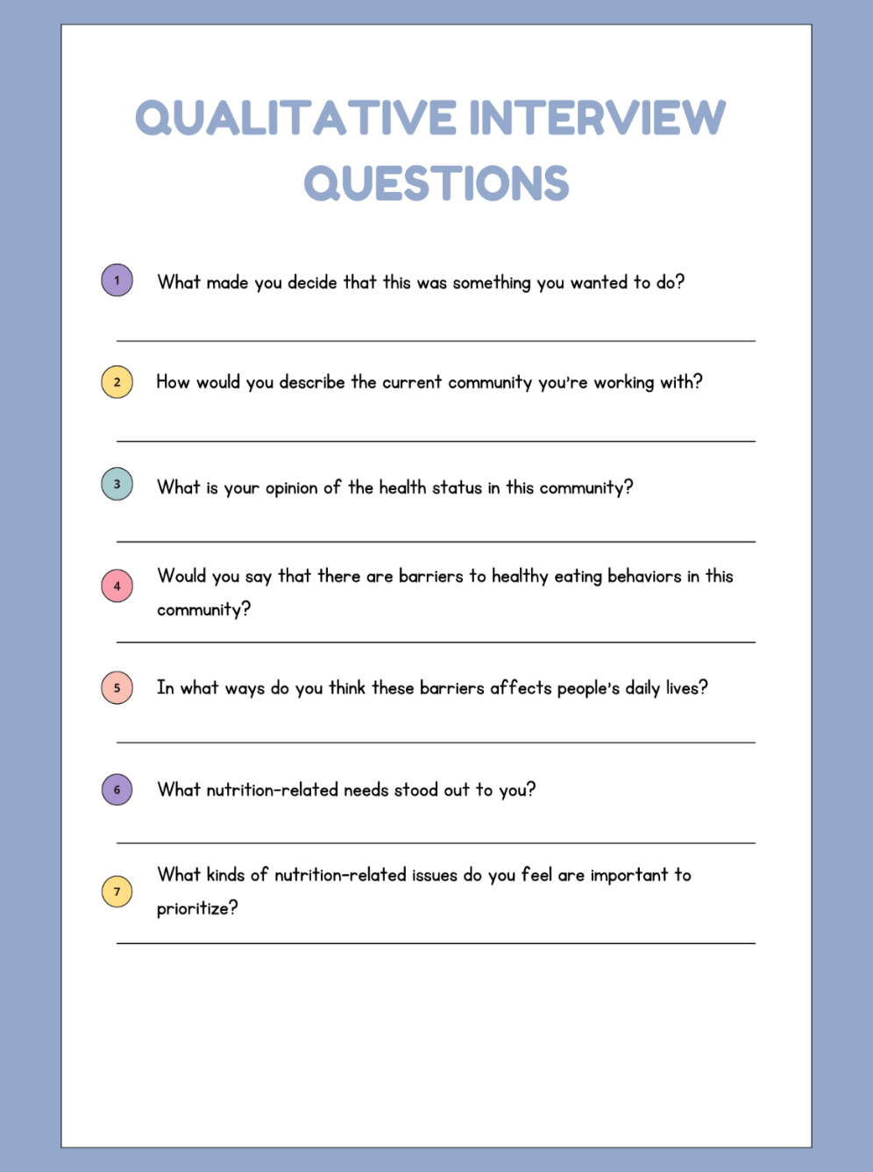 | 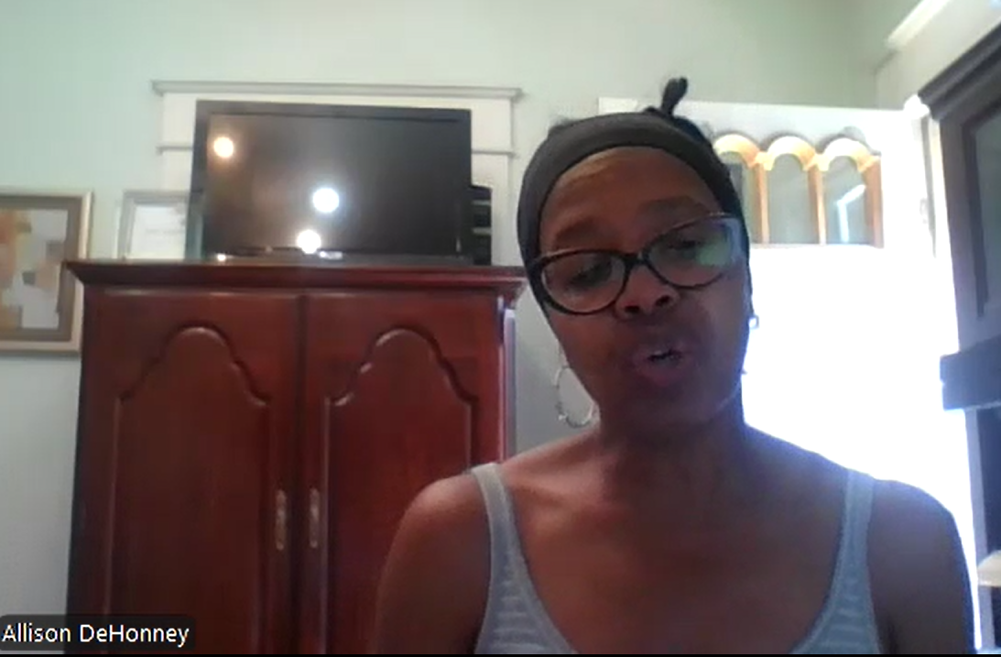
Step 2 was assessing the needs of the community. As the place where I was doing my SEL is very protective of their population, I wasn’t able to interview any of them. However, I did manage to interview the CEO of Buffalo Go Green, Allison DeHonney. Through this interview, she mentioned that one of the most important needs of the community that needs to be addressed (other than food accessibility) is lack of nutrition-related education, especially when it comes to making recipes using healthy, nutrient-dense produce.
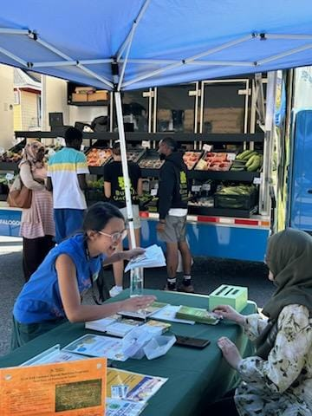 | 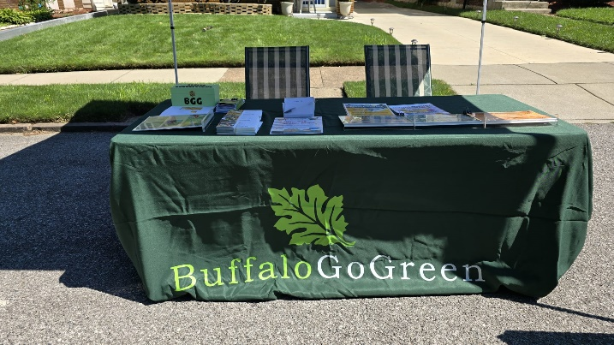  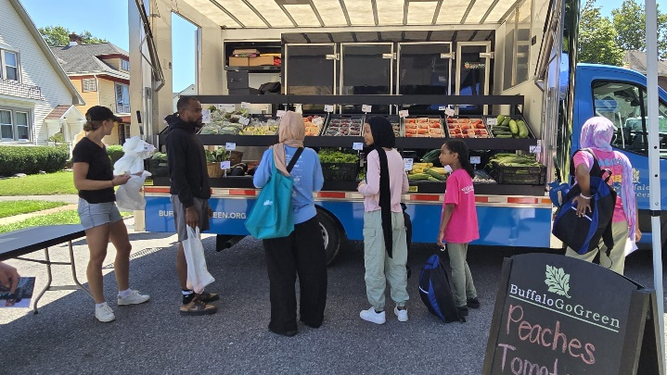
Step 3 was implementing the nutrition education lesson at the Community Health Center of Buffalo. I worked on creating easy-to-make, low budget recipe cards, with the ingredients that customers can get from our mobile market. I discussed the importance of fruits and vegetables in reducing the risk of various chronic diseases, educated people on how to prepare the recipes, and discussed the importance of food in our health.
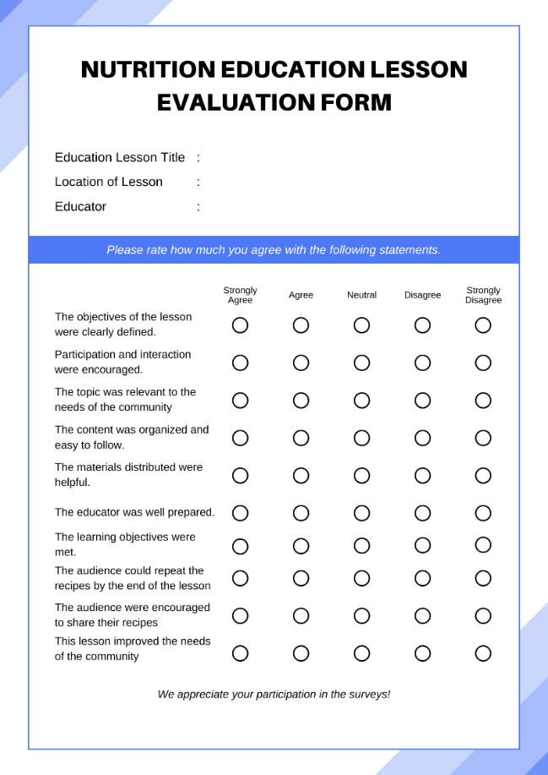
Step 4 was evaluating the nutrition education lesson via the survey above

Reflection
Utilizing proper planning steps for the nutrition education program was interesting as this was the first time that I followed a methodical process of providing nutrition education. The Nutrition Care Process is probably the only step-by-step process I’ve applied and it was on case studies, which were based on actual people, but I wasn’t conducting the entire process myself.
I’ve realized that I perform better when following a stepwise process. It keeps my brain organized and I can manage my time better. After knowing the community, I was going to use to conduct a nutrition education lesson, I moved on to the needs assessment of the community which I found out via an interview with Allison DeHonney, the CEO of Buffalo Go Green. She discussed why she got into this business, the nutritional and health status of the community she’s working with, the barriers the community is currently facing, and the nutritional needs that are important to prioritize. She mentioned the East Side of Buffalo needed to be educated on nutrient-dense produce, and easy ways they can prepare meals with the produce they buy from our mobile market. This was something I decided to give my lesson on.

