Ayesha Khan
ND 616 – Food Systems or Service Supervised Experiential Learning
Competency 7.1
Assumes professional responsibilities to provide safe, ethical and effective nutrition services (D)
Competency 7.2
Uses effective communication, collaboration, and advocacy skills. (D)
Activity
These competencies were met by giving a presentation on Time-Temperature Abuse in Food Safety.
Reflection
Time-temperature abuse is an essential topic to address as it often occurs in the food industry. After talking with my preceptor, I figured that this was the right topic to give a presentation on. I had also planned on having the kitchen staff be present for the lecture, but unfortunately, they had called off sick.
When food is left out at room temperature for extended periods, harmful bacteria grow rapidly, leading to the development of foodborne illnesses. Addressing time-temperature abuse in food is crucial because it significantly reduces the risk of foodborne illness and lowers the chance of food spoilage and quality decline.
I had fun creating the PowerPoint slides and giving the lecture was also enjoyable. Normally, I don’t find speaking in front of an audience to be fun, but since I’ve been working with the King’s Dining staff for several weeks now, it was a pleasant experience. We ended up having a great discussion on the types of food that are shelf-stable and could be left out at room temperature and what foods should be refrigerated.

Pictures can be viewed below!

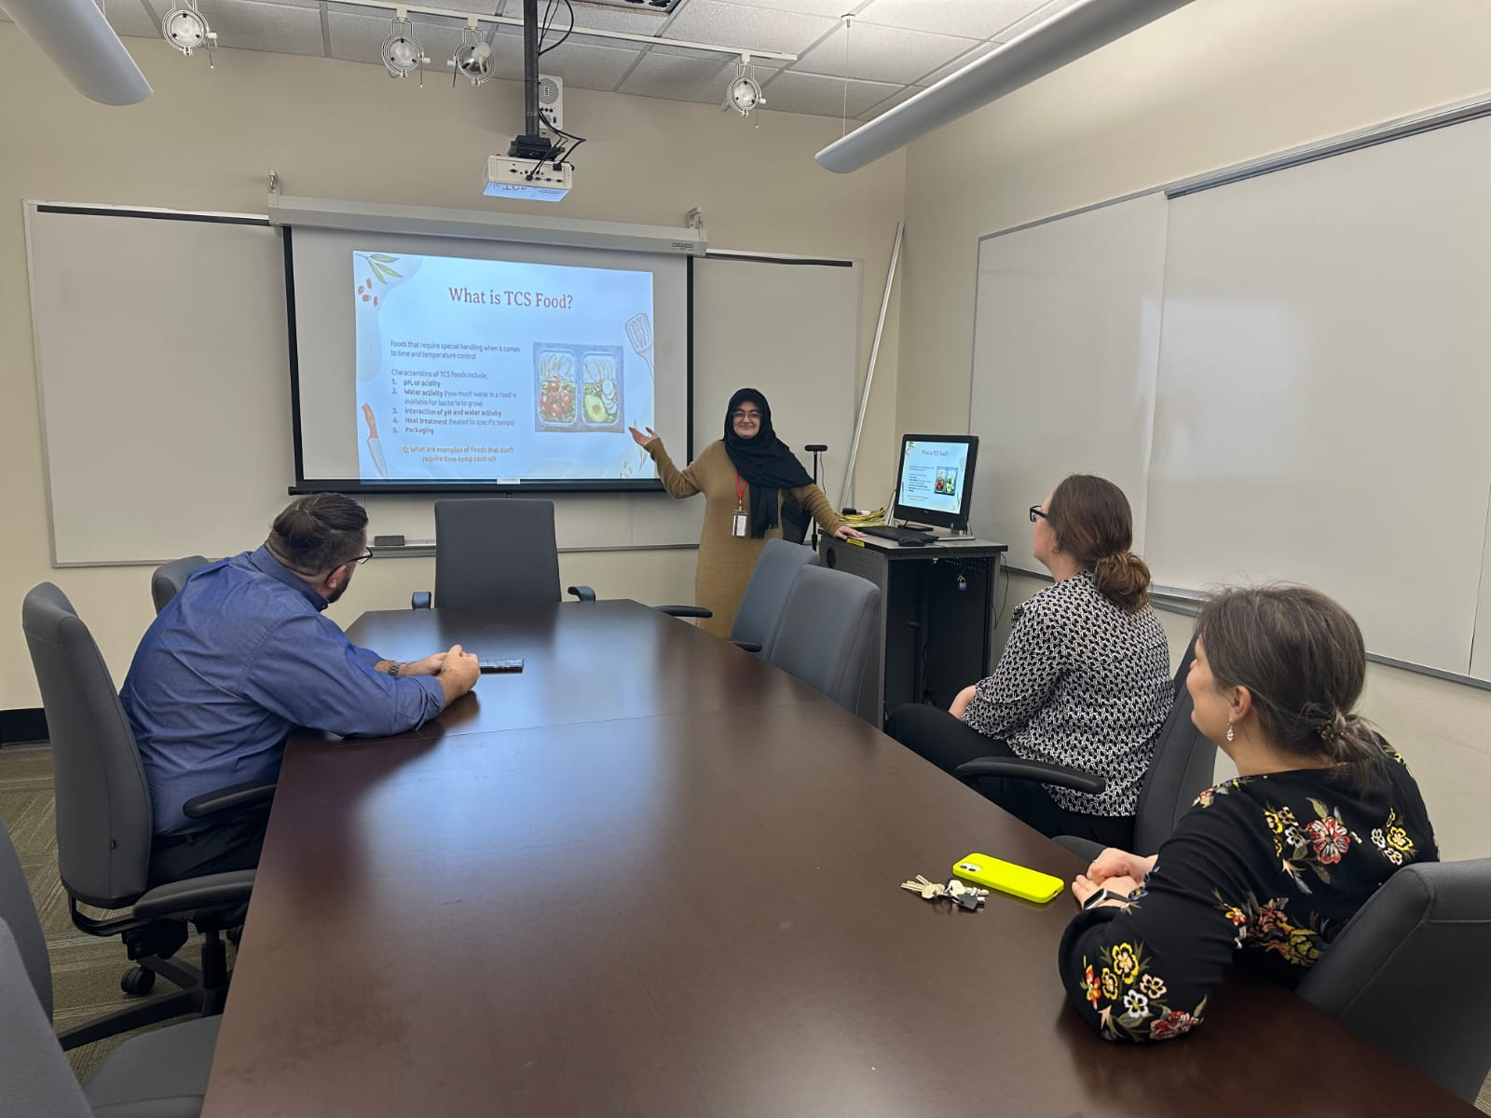

In the picture above, I’m giving a presentation of Time-Temperature Abuse in Food Safety to the staff of King’s Dining.

