**Adopt-An-Athlete Project**

**Ayesha Khan**

**NUTR530/ND606**

**King’s College**

**Part 1 – Nutrition Assessment**

1. Selecting an Athlete & Preparing for Assessment

The athlete chosen for this project was a 19-year-old girl named Sarah Shehryar, who plays basketball competitively. A list of interview questions was developed, keeping the five Nutrition Care Process (NCP) assessment domains in mind (Table 1). The athlete was contacted and offered the choice of being interviewed in person, via Zoom, or by phone.

|  |  |  |  |  |
| --- | --- | --- | --- | --- |
| **Table 1. NCP Assessment Domains** | | | | |
| **Food/ Nutrition-Related Hx**  Food and nutrient  intake, food and nutrient administration, medication, complementary/alternative medicine use, knowledge/beliefs, food and supplies  availability, physical activity, exercise / sport training, nutrition  quality of life | **Anthropometrics**  Height, weight, body mass index (BMI), growth pattern indices/percentile ranks, and weight history | **Biochemical data, Medical Tests, Procedures**  Lab data (e.g., electrolytes, glucose) and tests (e.g., gastric emptying time, resting metabolic rate) | **NFP Findings**  Physical appearance, muscle and fat wasting, swallow function,  appetite, and affect | **CLIENT Hx**  Personal history, medical/health/  family history, treatments and complementary/alternative medicine use, and social history, sport / exercise history |

*(The list of Interview Questions is in Appendix 1)*

2. Conducting the Nutrition Assessment

Zoom was used to conduct the Nutrition Assessment. A series of questions were asked, relating to Sarah’s anthropometrics, food and nutrition-related history, sports history and client history.

**Anthropometric Data**

Her self-reported height is 5’8” (172 cm) and weight is 132 lb. (60 kg). The latter was measured on a digital weight scale. Her Body Mass Index (BMI) is calculated as follows,

BMI = [60 ÷ (1.72)2]

BMI = 20.2 kg/m2

This puts Sarah in the normal weight category

Her weight 3 months ago was estimated to be around 138 lb., meaning she lost 6 lb. in 3 months. It’s important to know that Sarah doesn’t accurately remember her weight from so many months ago.

**Biochemical Data**

No lab values could be obtained. However, Sarah mentioned that her iron levels had been low for a while, which is why she started taking iron supplements.

**Nutrition-Focused Physical Findings**

No difficulties in swallowing or eating.



**Client History**

Sarah is a 19-year-old girl, who is currently in her final year of A’ Levels. This is an educational framework that is part of the Cambridge International Examination (CIE) system. Being from Pakistan, her main language is Urdu via which she communicates. She is currently the captain of her basketball team and her goals are to “get better at dribbling” and eventually play nationally.

In terms of her medical history, Sarah mentioned having a history of iron-deficiency, which has improved. Her mother is pre-diabetic and both her maternal grandparents have type 1 diabetes. She is currently not on any medication.

**24-Hour Recall**

Her dietary intake was assessed using the 24-hour recall method and is shown below.

|  |  |  |
| --- | --- | --- |
| **Table 2. 24-hour Recall** |  | |
| **Time** | **Menu** | **Amount** |
| Basketball Training Camp | Bananas before training  Water after training | 2 small  2 cups |
| Breakfast | Boiled eggs  Coffee with sugar  Orange juice | 2  1 tsp  1 cup |
| Midday Snack | Banana | 1 medium |
| Lunch | **Sandwich:**  Bread, white  Cheese  Chicken  Lettuce  Tomato  Water | 2 slices  1 slice  3 oz  2 leaves  2 slices  2 cups |
| Afternoon Snack | Tea with,  Milk, whole  Sugar  Cake rusk | ½ cup  1 tsp  1 rusk |
| Dinner | **Pasta dish:**  Pasta  Chicken, diced  Tomato Sauce  Water | 1 cup  2 oz  ½ cup  2 cups |

**Additional Information**

Sarah has stated that she loves sweets and used to snack on them all the time, but stopped recently once she started taking her multi-vitamin supplements. She loves eating “cheesy” foods like pizza, and pasta as well. She mentioned liking a few vegetables like spinach and eggplant. She doesn’t like rice too much and avoids it. In terms of food allergies and intolerances, Sarah has none, however, she avoids nuts because she says “they cause breakouts” on her skin.

She’s currently taking iron supplements every other day and a multi-vitamin supplement daily. She started on the former because she’s had a history of iron-deficiency. During the interview, Sarah mentioned that she “has no knowledge regarding nutrition or food intake” and that she doesn’t believe “counting calories” or “tracking food intake” is necessary. She makes sure to eat something a couple of bananas before her training, so her performance doesn’t suffer and eat a protein snack or meal after training. Her main “sports food” that she has during these camps are boiled eggs and bananas. She just eats “based on vibes”, meaning how she’s feeling at the moment.

In terms of hydration, she doesn’t properly track her water intake. The amount of water she drinks varies with the seasons. For example, when she has camp during the winter season as she “doesn’t get that thirsty”, so she drinks very less. In summer she drinks a lot more water but it still varies. She doesn’t drink water before practice but she does during quarters and after she’s done with training. She mentioned during the interview that she doesn’t take any sports drinks or electrolytes during these camps. She has no issues with accessibility of nutrient-dense food and sports drinks. Sometimes her mother makes the meals, and sometimes she makes something for herself.

Her training camps last 2 hours, in which she does 3-4 rounds of running around the court, layups, dribbling, and shooting drills, and a 1-hour match, which lasts longer or shorter, depending on everyone present at camp.

**Analysis of 24-Hour Recall**

Sarah’s dietary intake was analyzed using a complete nutrient analysis software (i.e., Cronometer) and the data extracted is shown below.1

|  |
| --- |
| **Table 3. Nutrient Analysis of the 24-hour Recall (Cronometer)** |
|  |
| The calories consumed from each of the macronutrients is shown below,    Her intake of energy and macronutrients are as follows,   * Total calories: 1563 kcal/day * Protein intake: 91.5 g/day * Carbohydrate intake: 211.4 g/day * Fat intake: 42 g/day |

**Analyzing Sarah’s Food Group Servings**

Sarah’s intake between the different food groups varies widely. She consumes adequate servings of meat in the form of boiled eggs and chicken (around 8 servings). Her intake of grains is around 6 servings, which is up there, however, she doesn’t consume any wholegrains. Her intake of dairy and vegetables is practically non-existent. She uses lettuce leaves and slices of tomatoes in her sandwiches which isn’t sufficient. The only time she’s taking milk is with her tea. Sarah does eat fruits consistently. Before training she has 2 bananas and later, during breakfast, she has 1 cup of orange juice. She also eats another banana as a midday snack. That brings her to around 6 servings of fruit.

**Calculating Sarah’s Energy, Macronutrients, and Fluid needs**

*(Check Appendix 2 for calculations)*

* 2692.28 kcal/day
* Carbohydrate intake will be 420 g
* Protein intake will be 84 g/day
* Fat intake will be 77 g/day
* Fluid intake 4-6 L/day

3. Written Component/Documenting Data

**Assessing Sarah’s Current Dietary Pattern and its Adequacy Compared to Evidence-Based Guidelines**

Sarah is the captain of the basketball team and plays competitively. She goes to training camp early in the morning, which lasts for 2 hours. There, she takes part in moderate-to-high intensity training. Sarah’s personal goal is to practice consistently to “get better at dribbling” and eventually play nationally. She mentioned that the reason for this goal is that whenever there is a break in her training e.g., during exam season or holidays, her dribbling gets rusty. She wants to get better so her gameplay is smoother.

Sarah’s current dietary pattern shows that her intake of carbohydrates and energy is inadequate. She is expending more energy than what she’s consuming, which puts her in a negative energy balance, resulting in a calorie deficit.2 She lacks several vitamins and minerals in her diet. However, she is taking an iron and multi-vitamin supplement to meet recommendations. She will need to introduce these micronutrients into her diet gradually and not be dependent on supplements to meet her needs. Her daily fluid intake is inadequate and she doesn’t take electrolytes. Plain water is less effective at restoring euhydration. This refers to having a state of optimal water content in the body, where it isn’t dehydrated or overly hydrated.3 Sarah will need to work on her dietary and fluid intake.

Keeping her current dietary intake in mind, as well as the energy, fluid, and macronutrient needs that were calculated for someone of her age and training level, her current dietary intake falls short. Her energy intake is 1563 kcal, which is well below her recommended intake of 2692 kcal. Her carbohydrate intake is around 211 grams, which is also well below her recommended 420 grams. Keep in mind, that for an athlete like her, engaging in intense physical activity and training, she needs to maintain carbohydrate and protein intake should fall within the range of recommendations. This is because carbohydrates are the primary source of fuel for the body and are crucial for restoring depleted glycogen stores and facilitating muscle regeneration after exercise, particularly when paired with protein. Surprisingly, her protein intake is 91.5 grams, which fall slightly above her recommendation of 84 g/day.

**Analysis of the Assessment Tools Used**

24-Hour Recall

A tool used to assess Sarah’s dietary intake. While it is quick to use, cost-effective and can help identify nutrient deficiencies, a snapshot of her diet does not really represent her typical dietary patterns.4 This kind of tool is also prone to recall bias, which is something I noticed when interviewing Sarah. Since she doesn’t believe in counting her calories or amount of food consumed, it was trickier to get the detailed picture of what she had at every meal time.

Malnutrition Universal Screening Tool (MUST)

This kind of tool is used for screening particularly and is not a diagnostic tool.5 It is designed to identify those at risk of malnutrition. Sarah doesn’t recall her weight 3-6 months ago so it isn’t clear whether she’s at risk for malnutrition or not. The estimate weight she gave showed her at a low-risk category. However, there might be a risk of that changing if she doesn’t tweak her fluid and dietary habits.

Cronometer

This app was used to analyze Sarah’s dietary intake. It has detailed tracking, barcode scanning, and the ability for athletes to customize nutrient targets.1 The downside to this nutrient analysis tool is that it has a smaller food database. While entering her 24-hour recall into the database, I had some difficulty finding the right foods. This tool also doesn’t directly integrate with training apps, which can be a disadvantage for athletes.

ADIME – Note

This template gives structure to documentation of the different steps of the NCP- Sarah’s nutrition assessment, diagnosis, interventions and monitoring and evaluation. It neatly captures all the essential data and tracks progress effectively. The downside to this structured format is that there isn’t much space for subjective data, which can sometimes include very useful information. It took me some time to fill out the entire form.

**Sarah’s Diet Order/Regimen**

After conducting the interview and assessing Sarah’s 24-hour recall, she has a low-calorie and low-carbohydrate diet order

**Assessment of Sarah’s Diet Order/Regimen**

I don’t agree with Sarah’s current diet order. This is because, for someone of her age and training level, her current dietary intake falls well below what the evidence-based guidelines recommend. I would prescribe a high-calorie, high-carbohydrate diet order to fuel her intense physical activity and aid in muscle recovery.

**Determining Sarah’s Nutrition Risk Category**

According to the Malnutrition Universal Screening Tool (MUST), Sarah’s nutrition risk category is low. Her height, weight, BMI, and her weight 3-6 months ago was inputted into the tool. Unfortunately, Sarah doesn’t remember what her exact weight was 3-6 months ago, so she gave an estimate, which was around 138 lb.

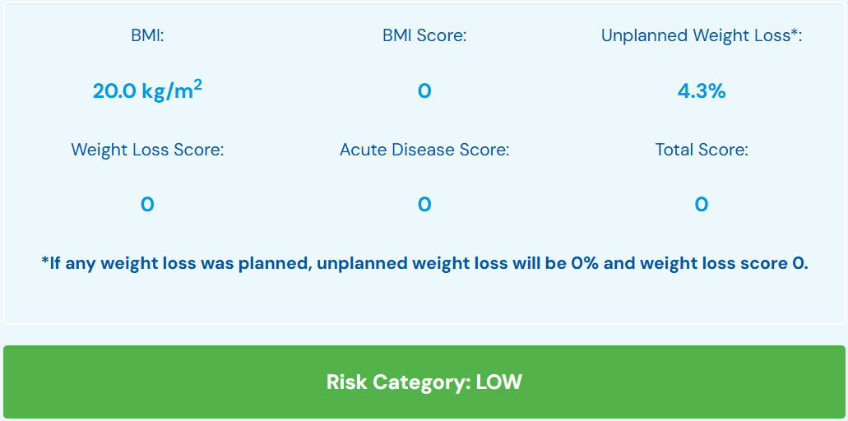

From the interview and assessment that was conducted, it seems clear that Sarah doesn’t believe in counting calories and assessing her food intake in depth. She mentioned having no knowledge of sports nutrition or nutrition in general. She eats “based on vibes” but she does make sure to eat bananas before her training camp and eats boiled eggs or some other source of protein afterwards. She doesn’t track her intake of water before, during or after training. This is especially true during the winter, where she doesn’t feel as thirsty, due to the cold weather. She doesn’t eat or drink anything during practice matches due to digestive discomfort. She doesn’t consume much throughout the day either, as assessed from her 24-hour recall, which is both less in carbohydrates and energy. Keeping all of this in mind, I feel like her risk category can go to medium if she continues to neglect fueling properly.

**Assessment of Your Assessment Appointment Preparation**

Assessment preparation was adequate. I made sure I had all the assessment tools during the interview (e.g., 24-hour recall). While I did ask about her beliefs regarding nutrition, it was unfortunate that I wasn’t able to do an in-depth interview on her beliefs regarding nutrition and its relation to sports. That is one of the additional questions I would have asked.

Some other questions I would’ve asked if I had time include the following,

**Q. Are you aware of any potential side effects of supplements?**

**Q. Are there any specific nutrients you are concerned about, such as carbohydrates, proteins, or fats?**

**Q. Are there any specific hydration preferences you have, like electrolyte drinks or flavored water?**

The purpose of including these questions would be to gain a deeper understanding of her knowledge regarding nutrition and whether there are any misconceptions that need to be cleared up.

**Part 2 – Nutrition Diagnosis**

Three diagnoses were identified after conducting Sarah’s nutrition assessment,

1. Inadequate energy intake (NI-1.2)
2. Inadequate carbohydrate intake (NI-5.8.1)
3. Food and nutrition-related knowledge deficit (NB-1.1)

The follow PES statements have been crafted below,

**PES Statement #1**

Inadequate energy intake (NI-1.2) related to food and nutrition-related knowledge deficit (NB-1.1) regarding meeting energy requirements for high-intensity training as evidenced by 24-hour recall showing the athlete’s consumption of 1563 kcal/day compared to the recommended intake of 2692 kcal/day

**PES Statement #2**

Inadequate carbohydrate intake (NI-5.8.1) related to food and nutrition-related knowledge deficit (NB-1.1) regarding appropriate fueling via carbohydrates as evidenced by 24-hour recall intake of 211.4 g/day compared to the recommended intake of 360-600 g/day

**PES Statement #3**

Food and nutrition-related knowledge deficit (NB-1.1) related to lack of prior nutrition-related education regarding proper fueling for high-intensity training as evidenced by the nutrition assessment showing lack of education regarding energy and macronutrient requirements for high-intensity training

**Part 3 – Nutrition Intervention & Monitoring**

1. Develop a Nutrition Care Plan

A follow-up appointment scheduled with Sarah for the 22nd of April, 2025, to discuss findings and recommendations via Zoom. The topics to discuss include,

* Increase energy consumption to recommendations
* Increase carbohydrate intake; with the incorporation of wholegrains
* Nutrition education on the importance of adequate nutrient intakes for proper fueling before, during, and after training/games
* Increase intake of fluids to meet needs

**Nutrition Prescription (NP-1.1)**

|  |  |
| --- | --- |
| **Table 4. Athlete’s Nutrition Prescription** | |
| **ENERGY & NUTRIENTS** | **RECOMMENDATIONS** |
| Calories/Energy | 2692 kcal/day |
| Carbohydrates | 360-600 g/day |
| Proteins | 72-84 g/day |
| Fats | 60 g/day |
| **FLUID INTAKE** | 4-6 L/day |

Pre-training camp, she should consume a high-carbohydrate and protein snack to optimize her performance and a high-carbohydrate and high-protein snack after her training. For someone of her age and weight, she should consume 300 – 600 mL (10–20 oz) of fluid, 2-4 hours before training camp. Throughout the day, she should consume 4-6 Liters of fluid. Her 3-day meal plan will be addressing both her micro and macronutrient needs. However, as I don’t have her biochemical data/lab history, she will stick with her supplements that she’s been taking.

**3-Day Meal Plan**

*(Details on the amounts of different foods is available in Appendix 3)*

***DAY – 1 Meal Plan***

**Pre-training Snack**: 2 bananas

**Post-training Snack**: Boiled egg and chocolate milk

**Breakfast**: Blueberry pancakes, maple syrup, butter, fruit cocktail

**Midday Snack**: Apple slices

**Lunch**: Naan, spinach, chicken breast, olive oil, minced garlic, salt, pepper, oregano, grated parmesan cheese, orange juice

**Afternoon Snack**: Tea with whole-milk, grapes

**Dinner**: Whole-wheat pasta, chicken breast chopped, mozzarella cheese, pasta sauce, olive oil, salt, pepper

***DAY – 2 Meal Plan***

**Pre-training Snack**: 2 bananas

**Post-training Snack**: Boiled egg and chocolate milk

**Breakfast**: Whole-wheat cereal with low-fat milk, sliced strawberries

**Midday Snack**: Fruit smoothie

**Lunch**: Chicken patty, 2 slices of bread, tomatoes, lettuce, cheddar cheese, mayonnaise, apple juice

**Afternoon Snack**: Tea with low-fat milk, wheat crackers with peanut butter and sliced bananas

**Dinner**: Chicken Caesar salad with whole-wheat pasta, strawberry yogurt

***DAY – 3 Meal Plan***

**Pre-training Snack**: 2 bananas

**Post-training Snack**: Boiled egg and chocolate milk

**Breakfast**: Buttermilk waffles with chocolate chips, peach

**Midday Snack**: Apple slices with peanut butter

**Lunch**: Whole-wheat pasta, sliced chicken breast, chopped spinach, diced tomatoes, olive oil, salt, pepper, garlic cloves

**Afternoon Snack**: Tea with ½ cup whole-milk, wholegrain chocolate chip cookies

**Dinner**: Sliced roast beef, burger bun, sliced tomato, cheddar cheese slice, lettuce, mayonnaise, orange juice

I kept the bananas and boiled eggs for all 3 days, as she mentioned that they were her go-to snacks for sports and preferred to keep it that way.

2. Interventions/Monitoring and Evaluation

Interventions for each of the PES statements were developed. The interventions targeted the root causes of the nutrition problems i.e., the etiology. Monitoring and evaluation criteria are also given below.

**PES Statement #1**

Inadequate energy intake (NI-1.2) related to food and nutrition-related knowledge deficit (NB-1.1) regarding meeting energy requirements for high-intensity training as evidenced by 24-hour recall showing the athlete’s consumption of 1563 kcal/day compared to the recommended intake of 2692 kcal/day

**Intervention**

Content related nutrition education (E-1.1)

Provide information about the importance of maintaining energy intake before, during, and after high-intensity training. Discuss snacks that can provide Sarah with high energy to meet her recommended intake of 2692 kcal/day. Advise her on day-to-day consistency in meeting energy levels during training camps and games.

**Monitoring & evaluation criteria**

Changes in Sarah’s nutrition knowledge about the energy-content of foods/snacks. A nutrition questionnaire will be provided to the athlete after the counseling session and her answers should be at least 85% correct.

**PES Statement #2**

Inadequate carbohydrate intake (NI-5.8.1) related to food and nutrition-related knowledge deficit (NB-1.1) regarding appropriate fueling via carbohydrates as evidenced by 24-hour recall intake of 211.4 g/day compared to the recommended intake of 360-600 g/day

**Intervention**

Nutrition related skill education (E-2.2)

Instruct Sarah on the use of a food diary to keep a record of her carbohydrate intake. She should meet her recommended intake of 360-600 g/day.

**Monitoring & evaluation criteria**

Sarah will keep a food diary and will track her carbohydrate intake for a couple of weeks, with a focus on half of those carbohydrates being wholegrains. By the next appointment in 2 weeks, she should be meeting her carbohydrate needs 4 out of the 7 days of the week. Consider altering her method of tracking, if she fails to meet the goal. This can be by keeping a photographic food diary, which involves taking pictures of her food and recording nutrition information. This will be more fun and engaging for the athlete.

**PES Statement #3**

Food and nutrition-related knowledge deficit (NB-1.1) related to lack of prior nutrition-related education regarding proper fueling for high-intensity training as evidenced by the nutrition assessment showing lack of education regarding meeting energy and macronutrient requirements for high-intensity training

**Intervention**

Nutrition counseling based on motivational interviewing strategy (C-2.1)

Resolve Sarah’s ambivalence towards keeping track of her food intake for optimal performance. Elicit change talk about how to fuel herself properly before, during, and after high-intensity training and games to improve her gameplay. Clarify what she is willing to do to achieve her personal goals and how this can be tied to proper nutrition fueling.

**Monitoring & evaluation criteria**

Monitor and evaluate changes in Sarah’s self-efficacy at the next appointment in 2 weeks. Assess her motivation to keep track of her food intake for proper fueling before, during, and after training to fulfill her personal goals. Assess whether any ambivalence remains towards making nutrition-related changes.

**Lesson Title**: Proper Nutrition Fueling for Sustained and Optimal Performance

**Developed By**: Ayesha Khan

**Approved By**: King’s College, Diane Dellavalle

**Lesson or Class Description**

The lesson will discuss the importance of proper fueling before, during, and after training and games. Highlighting how crucial nutrition is for sports performance is necessary for Sarah, to resolve her ambivalence towards making nutrition changes.

**Participants (DESCRIBE who is the Client or Patient Group/Audience/Participants)**

The athlete is a 19-year-old girl, who is who is currently in her final year of A’ Levels. This is an educational framework that is part of the Cambridge International Examination (CIE) system.6 She is currently the captain of her basketball team and her goals are to “get better at dribbling” and eventually play nationally. She has training camp that last 2 hours, in which she does 3-4 rounds of running around the court, layups, dribbling, and shooting drills, and a 1-hour match, which lasts longer or shorter, depending on everyone present at camp. Sarah has mentioned that she “has no knowledge regarding nutrition or food intake” and that she doesn’t believe “counting calories” or “tracking food intake” is necessary.

**Type(s) of Learning Activities (LAs)**

* Designing different meals for pre-workout, intra-workout, and post-workout
* Looking up the food labels for the meals selected for pre-workout, intra-workout, and post-workout

**Mode of delivery:** Virtual

**Learning Objectives (What will clients / patients / audience / participants take away or be able to do by the end of your session?)**

Learning objective #1:

After this nutrition education lesson, Sarah will be able to understand the importance of proper nutrition fueling pre-workout, intra-workout, and post-workout, for optimal performance

Learning objective #2:

After this nutrition education lesson, Sarah will be able to create meals that can fulfill her carbohydrate, protein and energy needs throughout the day

**Key Content Points (what key info do the learners need to know to achieve your learning objectives? Aim for 3 main points)**

1. Understanding why proper nutrition fueling is necessary for optimal performance
2. Understanding the importance of each macronutrient in sports performance and recovery
3. How to read nutrition labels for different food products to identify and create good snacks and meals

**Materials (List what you will need for the session - visual aids, handouts, supplies, etc.)**

* Notebook and pen in case Sarah wants to note anything down
* Nutrition educational materials that Sarah can look at during the lesson
* Meeting will take place via Zoom on the laptop. We will share our screens so we can stay in sync for the entire lesson. Sarah will share her screen when reading food labels and creating meals for pre-workout, intra-workout, and post-workout

**Resources (current info used to prepare; use AMA citation style)**

American Heart Association. Food as Fuel Before, During and After Workouts. www.heart.org. Published 2015. <https://www.heart.org/en/healthy-living/healthy-eating/eat-smart/nutrition-basics/food-as-fuel-before-during-and-after-workouts\>

Dr. D. Week 2: Macronutrients for Exercise Carbohydrate (Ch 2); Protein (Ch 3); Fat (Ch 4). Accessed April 25, 2025. <https://moodle.kings.edu/pluginfile.php/1113990/mod_resource/content/0/Week%202%20Chapter%202%203%204_Carbohydrate%20Protein%20Fat%20and%20Exercise.pdf>

Better Health Channel. Sporting performance and food. Vic.gov.au. Published 2023. <https://www.betterhealth.vic.gov.au/health/healthyliving/sporting-performance-and-food>

Thomas DT, Erdman KA, Burke LM. Position of the Academy of Nutrition and Dietetics, Dietitians of Canada, and the American College of Sports Medicine: Nutrition and Athletic Performance [published correction appears in J Acad Nutr Diet. 2017 Jan;117(1):146. doi: 10.1016/j.jand.2016.11.008.]. *J Acad Nutr Diet*. 2016;116(3):501-528. doi:10.1016/j.jand.2015.12.006

FDA. How to Understand and Use the Nutrition Facts Label. *FDA*. Published online March 5, 2024. <https://www.fda.gov/food/nutrition-facts-label/how-understand-and-use-nutrition-facts-label>

**Class flow and set-up (consider flow of session, team work, virtual set-up, etc.  Make notes of additional prep needed ahead of time; room arrangements, technology needs, etc.)**

The delivery is virtual, so Zoom meeting will be created ahead of time and sent to the athlete. Nutrition education materials will be given to Sarah on the day of the lesson. Laptop will be checked earlier in the day to ensure it is at full battery before starting the lesson.

**Session Outline - Include TIMING - minutes for each section!**

**Introductions – 0.5 minute**

As Sarah and I know each other, the introduction will just be me thanking her for her time and allowing me to use her as the athlete for this project

**Icebreaker, establish rapport – 5 minutes**

I will ask Sarah if there’s anything she wants to discuss and needs clarification on. Talking in an upbeat manner with non-verbal cues such as smiling should help her feel more at ease before starting the lesson.

**Lesson outline – 10 minutes**

I will start by highlighting the objectives of this nutrition education lesson. Then I will request Sarah to open the nutrition education handouts so she can follow along to what I will be discussing. The topics covered will include the importance of macronutrients in sports performance and recovery. This is important to resolve Sarah’s ambivalence towards making nutrition-related changes to her diet. I will also teach her how to read nutrition labels of different food products.

**Learning Activities – 15 minutes**

1. I will have her design different meals for pre-workout, intra-workout, and post-workout and offer guidance where necessary
2. We will look up the food labels for the meals selected for pre-workout, intra-workout, and post-workout

**Discussion Question & Answers – 5 minutes**

Q1. Proper nutrition fueling pre-workout, intra-workout, and post-workout, for optimal performance is important. What problems can occur in an athlete if there is no proper nutrition fueling?

Q2. Protein-rich snacks are important for muscle growth and recovery. Are there any protein-containing snacks you enjoy or are open to consuming post-workout?

Q3. Maintaining recommended energy and carbohydrate intake is necessary for optimal sports performance. What kinds of carbohydrate sources are recommended for athletes and how can you easily incorporate some of these into your diet?

**Questions/Evaluation/Resources – 5 minutes**

Address any questions Sarah may have

Sarah will come forward to summarize key points of the session and share how she will use what she learned going forward / in the future. Teach-back method will also be used to assess how well Sarah has grasped the information.

Useful resource: <https://www.heart.org/en/healthy-living/healthy-eating/eat-smart/nutrition-basics/food-as-fuel-before-during-and-after-workouts#:~:text=Ideally%2C%20fuel%20up%20two%20hours%20before%20you%20exercise%20by:&text=Eating%20healthy%20carbohydrates%2C%20such%20as,and%20proteins%2C%20even%20healthy%20ones>.

**Personal Review of Lesson**

The lesson went smoothly. We were fortunate enough to have no technology or Wi-Fi issues. I did my best to resolve Sarah’s ambivalence towards making nutrition-related changes and by the end of the lesson, she seemed more inclined to try and make nutrition-related changes. Talking about how vital proper nutrition fueling is to her short and long-term goals was effective. Teaching her how to read food labels and create meals increased her self-efficacy.

I would keep the content of the lesson plan the same, since I believe it addressed most of Sarah’s questions. What I would do differently is try to conduct a nutrition education lesson in-person. We weren’t able to do so due to conflicts in our schedules.

**Part 4 – Project Evaluation**

I remember doing a community nutrition education plan few semesters back. It was somewhat similar to this but a bit less taxing, mainly because I had the help of my Community SEL preceptor. For this project, I had to plan, organize, and figure out things out on my own. As I was working with one athlete this time, it was more of a counseling session than community education.

One of the challenges I faced was conducting a one-to-one session with an athlete. This project required more in-depth assessment of the client and I had to use my best judgement to assess which areas she needed to work on for optimal sports performance. As I don’t have much experience in this area, it ended up being a bit challenging. This was partly due to the client not giving detailed responses to what I was asking. For example, I had to ask her 3 times about what she had for lunch, so I could assess her intake. She just mentioned having pasta so I had to further ask her “how many servings of pasta” and “what was in the pasta”.

Another challenge was creating a 3-day meal plan that fulfilled her energy, fluid and macronutrient intakes, which I had calculated during her assessment. It tends to get a bit tricky, trying to balance all the nutrients and energy needs properly in a 24-hour meal plan. I did the best I could to meet the requirements when planning meals for all 3 days.

An area of improvement on my part would be wording questions in a way that sound unbiased, specific, and non-judgmental. I do a decent job of not sounding judgmental when conversing with someone. However, I definitely feel like I could’ve worded my interview questions in a better way, so she could’ve felt more at ease with responding and providing more information than what she had given.

I feel like I’ve learned a few things in this project. This was the first one-to-one counseling situation I was in, so it was good practice for the future. This project positively impacted my future practice in the sense that I better understood how to work on tailoring meal plans to meet specific nutrient needs of patients/clients. I’ve also gotten better at wording information I want to get across to a patient. I’m slowly applying what I’ve learned over this Master’s program and hopefully it will get easier as I keep doing it!

If I could do this project over, I would actually see if I could pay a visit to her training camp, so I could have a better sense of the activities she takes part in and the intensity of her training. I would also take her to the supermarket to help her pick out foods and snacks she could see herself consuming and how to read food labels of different products. Overall, I’m pretty satisfied with how this project turned out.

**Appendix 1**

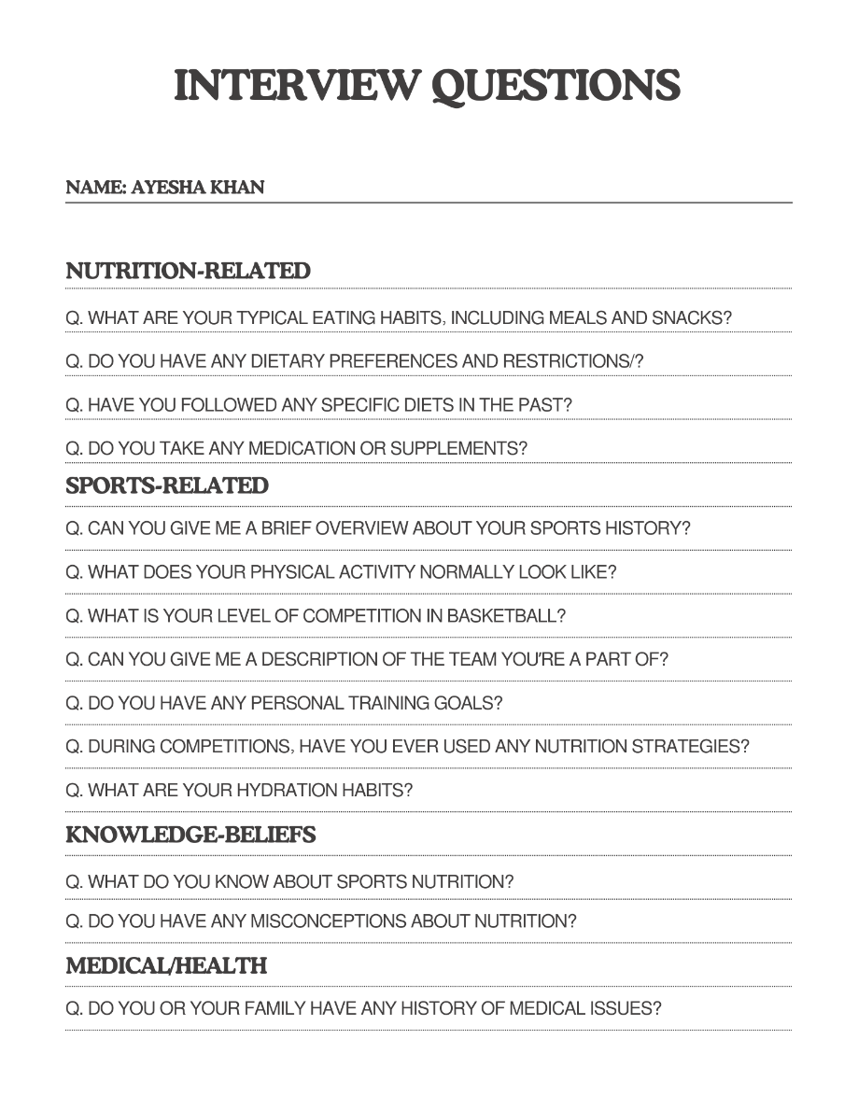

**Appendix 2**

**Calculating Sarah’s Energy, Macronutrients, and Fluid needs**

**Estimated Energy Requirements (EER)**

As Sarah is 19 years old, she is considered an adult. Hence, the energy equation used will be the following,

*Recommendation: EER = 511.83 – (7.01 × age) + (9.07 × height) + (12.56 × weight)*

EER = 511.83 – (7.01 × 19) + (9.07 × 172) + (12.56 × 60)

EER = 511.83 – (133.19) + (1560.04) + (753.6)

EER = 2692.28 kcal/day

**Carbohydrate Intake**

As Sarah is doing moderate- to high-intensity basketball training for 2 hours at camp, the recommended carbohydrate intake will be the following,

*Recommendation: 6–10 g/kg body weight*

60 kg × 7 = 420 g/day

420 × 4 = 1680 kcal from CHO

(1680/2692) ×100 = 62% of total calories

**Protein Intake**

As Sarah is doing moderate- to high-intensity basketball training for 2 hours at camp, the recommended protein intake will be the following,

*Recommendation: 1.2-1.4 g/kg/d*

60 × 1.4 = 84 g/day

84 × 4 = 336 kcal from PRO

(336/2692) ×100 = 12% of total calories

**Fat Intake**

The recommended fat intake will be the following,

CHO (62%) + PRO (12%) = 74%

100% - 74% = 26%

2692 × 0.26 = 700 kcal

700/9 = 77 g/day

**Fluid Intake**

Sarah mentioned during the interview that she doesn’t drink water before practice. However, she does take it during quarters and after practice. Her intake is around 500 ml of water during these camps, sometimes more and sometimes less, depending on the season and the day.

She takes part in Basketball drills and practice matches, so her MET value is around 9.3. This value is defined at the ratio of rate of energy expended during exercise to rate of energy expended at rest. Vigorous intensity exercise has an MET value of ~6.0. This tells us that Sarah takes part in high-intensity/vigorous physical activity.

Sarah has never measured her Pre- and Post- Training body weights, so we will assume the typical body water *weight loss of ½ lb. (= 8 fl oz). body weight every 30 min for a high-intensity training session.*

* Every 30 minutes = ½ lb. water weight loss
* Each camp lasts 2 hours, so her total water weight loss will be 2 lb.
* If her pre-exercise weight is 132 lb., her post-exercise weight will be 130 lb.
* Her total fluid intake during the 2-hour training camp is around 500 ml (16.9 fl oz.)
* Sweat Rate = (2 + 16.9) ÷ 2
* Sarah’s sweat Rate is 9.45 L/H

This shows that Sarah is not hydrating properly, as she is losing lb. She will need to hydrate more during her training sessions.

A 60-kg athlete should consume 300 – 600 mL (10–20 oz), 2-4 hours before exercise.

Adult women should take about 2.7 L/day, but for athletes like Sarah, who take part in vigorous intensity training, fluid intake should be around 4-6 L/day.

**Appendix 3**

**Day 1 Meal Plan**

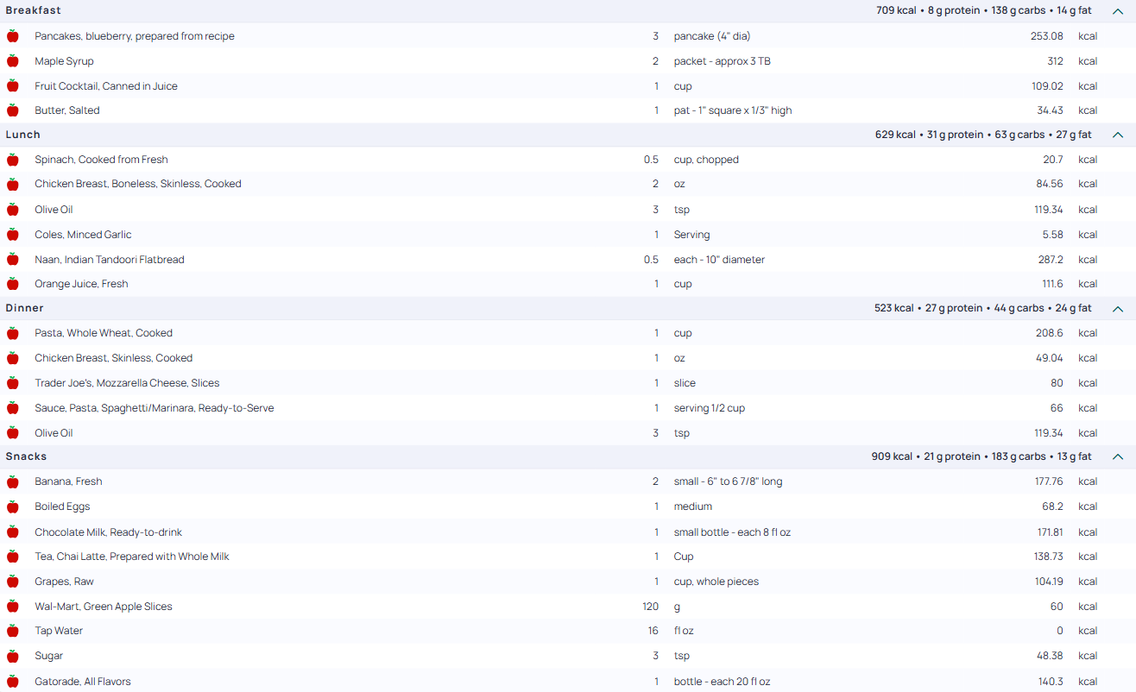

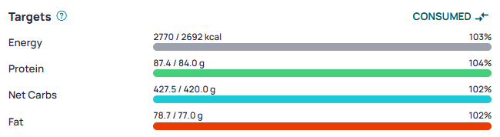

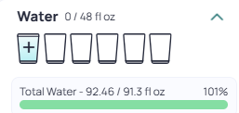

**Day 2 Meal Plan**

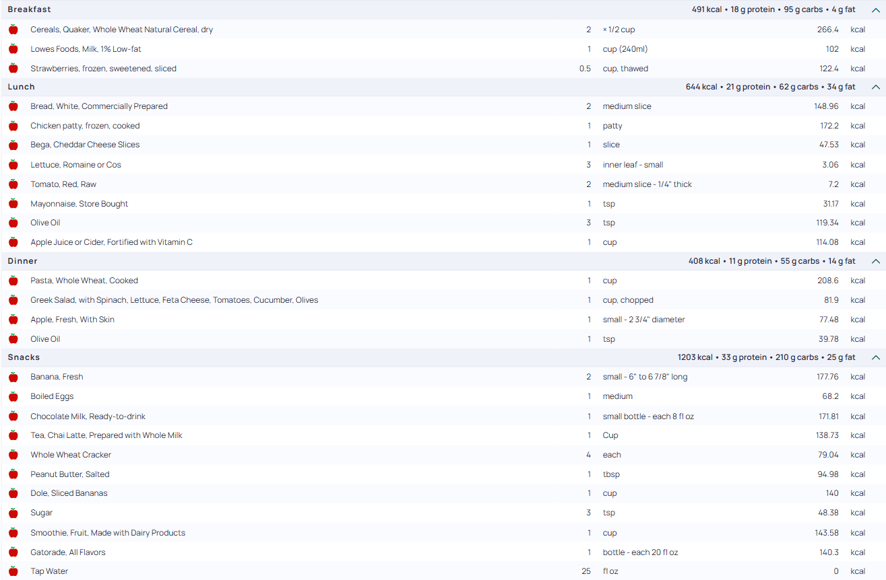

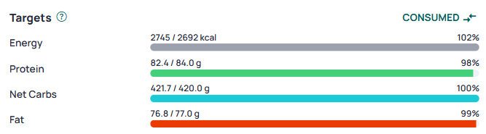

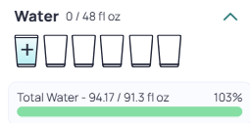

**Day 3 Meal Plan**

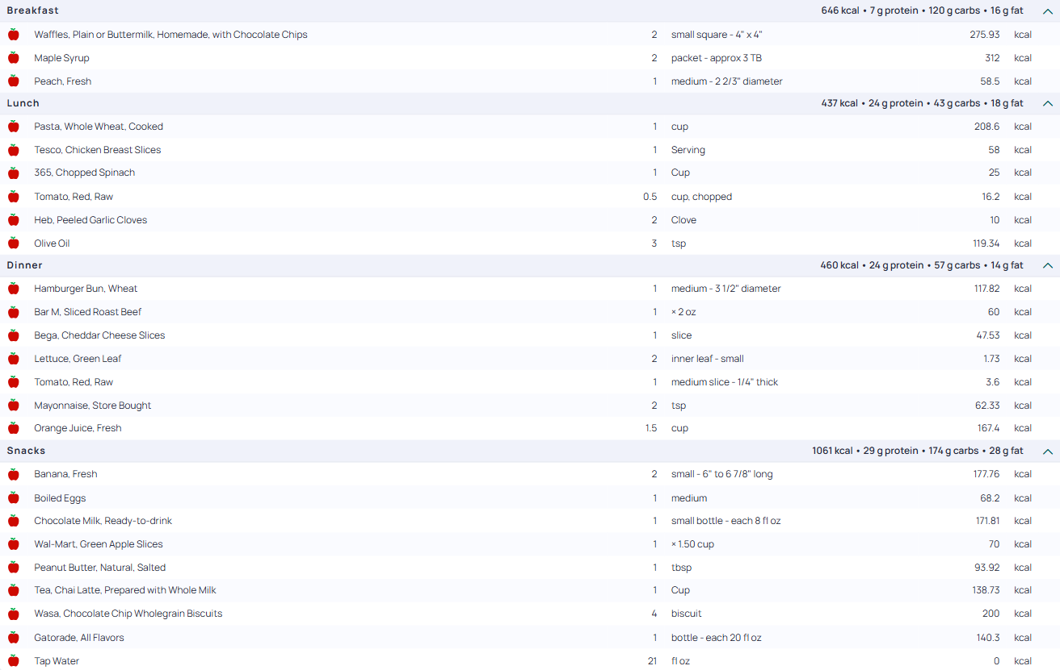

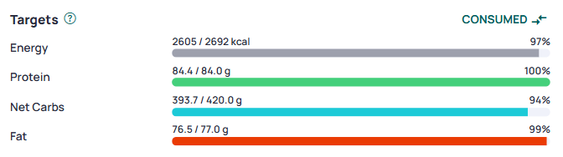

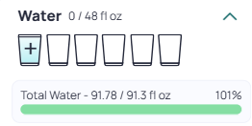

**References**

1. Cronometer: Eat smarter. Live better. cronometer.com. <https://cronometer.com/#dashboard>

2. Cleveland Clinic. What Is Calorie Deficit? Cleveland Clinic. Published December 21, 2021. <https://health.clevelandclinic.org/calorie-deficit>

3. McDermott BP, Anderson SA, Armstrong LE, et al. National Athletic Trainers’ Association Position Statement: Fluid Replacement for the Physically Active. *Journal of Athletic Training*. 2017;52(9):877-895. doi:https://doi.org/10.4085/1062-6050-52.9.02

4. 24-hour Dietary Recall (24HR) | INDDEX Project. inddex.nutrition.tufts.edu. <https://inddex.nutrition.tufts.edu/data4diets/data-source/24-hour-dietary-recall-24hr>

5. Bapen. “MUST” Calculator. BAPEN. Published July 17, 2023. <https://www.bapen.org.uk/must-and-self-screening/must-calculator/>

6. Cambridge International AS & A Levels. Cambridgeinternational.org. Published 2019. <https://www.cambridgeinternational.org/programmes-and-qualifications/cambridge-advanced/cambridge-international-as-and-a-levels/>

‌

‌

‌

‌

‌

‌