Ayesha Khan
ND 615- Community Nutrition Supervised Experiential Learning
08/19/24

Competency 2.1
Applies a framework to assess, develop, implement and evaluate products, programs and services. (D)
Activity
This competency was met by coordinating a community nutrition education lesson with my preceptor at the Community Health Center of Buffalo. I worked to develop the educational brochures and recipes, deliver nutrition education to the people who stopped by our table, and evaluate the success of the event.
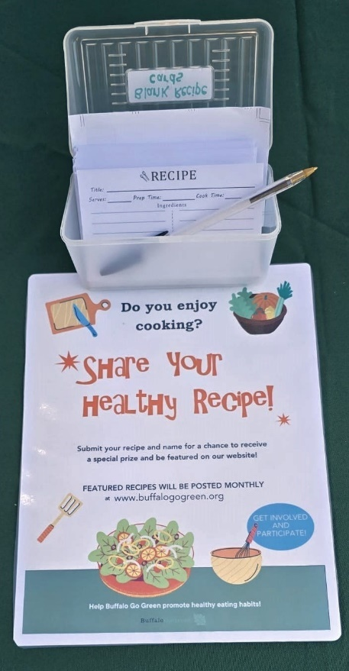 | 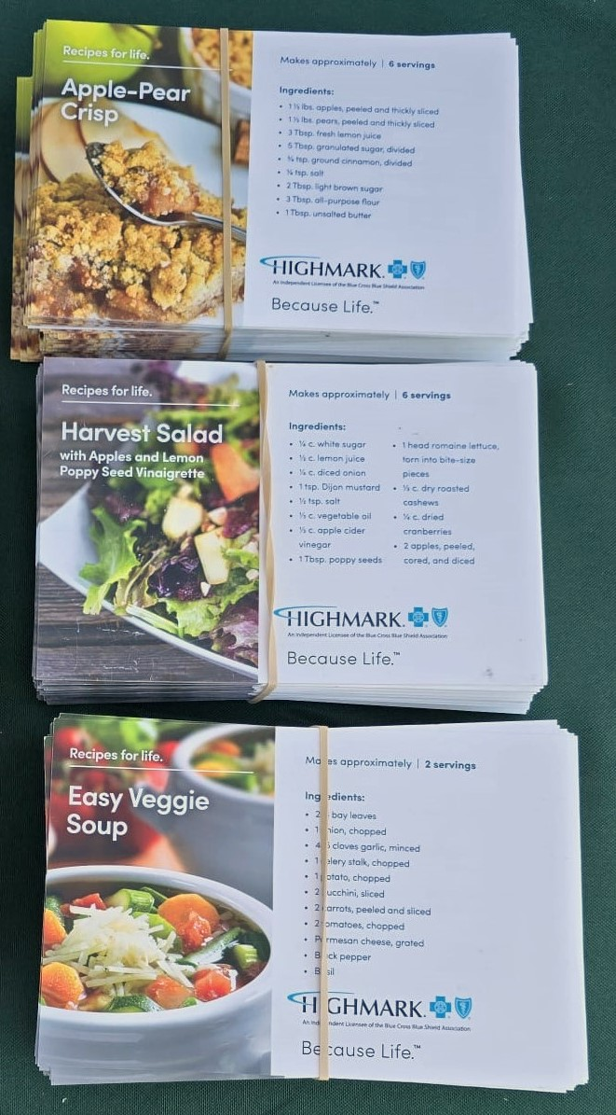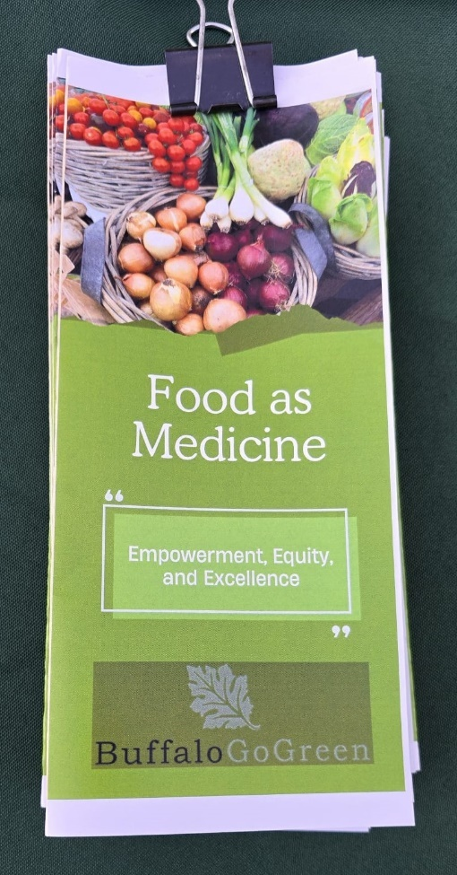  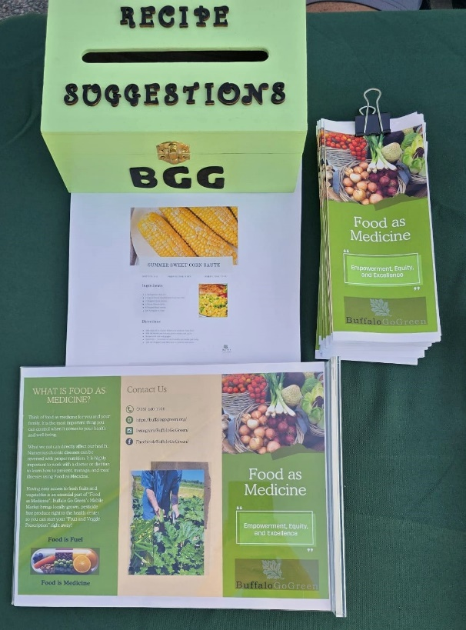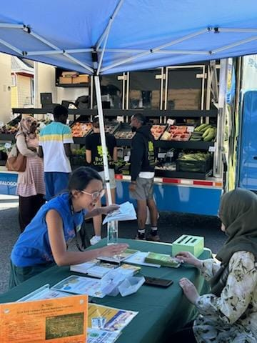  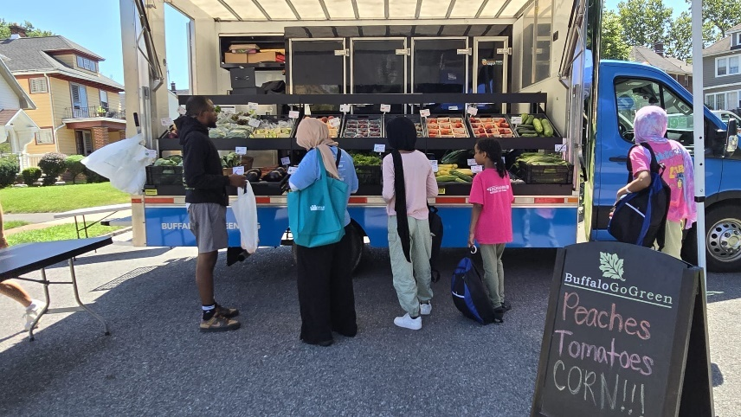
These pictures show the health fair where I gave my nutrition education lesson. I created the recipe cards and brochure on the concept of Food as Medicine. People came to our mobile market to purchase healthy and nutrient-dense produce.

Reflection
Planning and implementing this nutrition education program were probably one of the highlights of my SEL experience. I’ve never conducted a community nutrition program before. Being in charge of interviewing the stakeholders, prioritizing a problem to address, creating the material handouts, interacting with every customer/patient that stopped by, and directing them to our mobile market was probably the most effort I put in solo (other than my thesis). Of course, my preceptor helped with setting up the table and proofread the material handouts I’d be giving to the customers.
I remember how nervous I was when the first person approached our table. I don’t have much experience in public speaking so I was wondering how my lesson would be received. As soon as they approached the table, I greeted them and asked if they would like any recipes to which they said they’d love to. That bolstered my confidence and I was able to get into a pleasant conversation with them about importance of healthy produce and what kind of organization Buffalo Go Green was. I also explained the recipes in an easy way to understand. Then afterwards, I directed them to our mobile market for fruits and vegetables, which are the main ingredients in the recipes. I got into similar conversations with others who came by our table, including a group of first year medical college students.
Most of these customers were patients at the Community Health Center of Buffalo, where this event was taking place. People were also encouraged to submit any recipes they knew of. It was incredible, listening to how other use different produce, like zucchini and banana peppers, to make their meals. Since these are produce that I haven’t consumed before, I learned a lot about different ways to prepare them.
After the event, I evaluated the success of the nutrition education program. Things could’ve been improved in several areas. Firstly, the brochures weren’t printed properly from the inside and some of the recipes weren’t printed in card form. That’s something I couldn’t control since the CEO insisted, she print them. It was frustrating though. Secondly, I felt like I could’ve clarified things more simply or communicated better with the audience. Lastly, since I couldn’t do a proper nutrition education lesson/program, due to the community I was working with, I wasn’t able to adequately explain things or make the lesson more interactive. I couldn’t keep them for more than 5 minutes. However, I’d say the material that I distributed was very helpful and the content was easy to follow and organized.

