Ayesha Khan
ND 616 – Food Systems or Service Supervised Experiential Learning
Competency 5.3
Applies project management principles to achieve project goals and objectives (D)
Competency 5.4
Leads quality and performance improvement activities to measure, evaluate and improve a program’s services, products and initiatives (D)
Activity
These competencies were met observing and interpreting student feedback and survey data, discussing the reasons for why the results are as they appear, and how they can be used to improve services.
Reflection
Observing and interpreting survey is something I’m used to, so it was fun collecting the student feedback and other survey data with Lisa Blackwell and figuring out the reasons behind the results. A student feedback system called “Happy Or Not Surveys” was set up last year at King’s Court, Connerton’s and Susquehanna.
This survey is basically used to gauge customer satisfaction. What happens is that customers press a smiley face button to indicate whether they are very happy, happy, unhappy, or very unhappy with their recent experience. Kiosks were placed in three different locations at King’s College to monitor foot traffic and student satisfaction with meal services.
Surveys called the “Voice to Vision” were also completed to monitor student preference for dining facilities and services. One of the survey data collected last year was on the dining frequency of students at locations on and off-campus. The results observed were between students of different class years (First Year, Upper Class, and Graduate). For example, in this study, the percentages of students visiting the on-campus convenience stores was 4% for First Year, 9% for Upper Class and 33% for Graduates. From that we can come to conclusion that Graduates probably prefer making their own food and eating at home, while the First Years and Upper Class probably prefer eating in the dining hall or other food locations on-campus. Another example is that the percentages of students visiting off-campus national brands was 7% for First Year, 3% for Upper Class and 33% for Graduates. From this, we can assume that the percentage of Graduates is way higher than the other two years likely because Graduates probably have their own method of transport which means easier access to off-campus stores and restaurants.
Data on both “Voice of Vision” and the ‘Happy Or Not” surveys can help to gauge student preference and satisfaction, which can then be used to bring about improvements and positive changes to increase student satisfaction and dining experience. These surveys are conducted frequently, so the staff at King’s Dining can monitor changes in trends and then adjust accordingly.
I learned a lot from observing the different survey results that came in and while I wasn’t able to get access to most of the data, due to privacy reasons, I was able to see the data I mentioned above, which was enough for me to get the idea that student feedback is vital to continue improving the quality of dining services at King’s. Lisa mentioned that from April they will be conducting student focus groups for feedback to further improve the dining services at King’s, which is great!

Pictures can be viewed below!
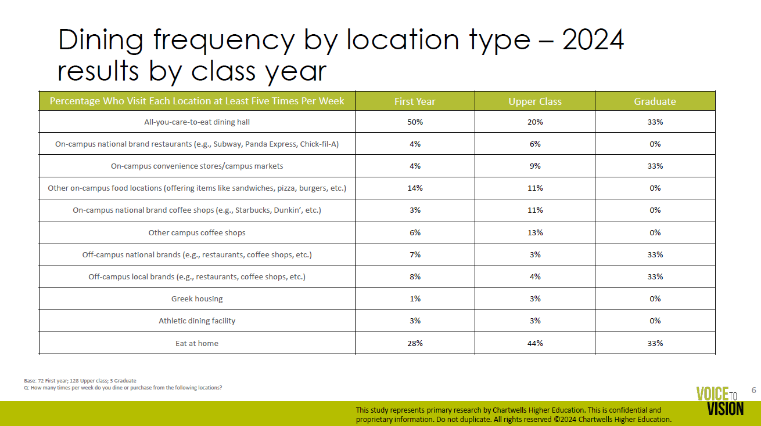

The picture above shows a student survey conducted in 2024 for the percentage of students who visited different dining locations on and off-campus. The students in the survey study were First Year, Upper Class, and Graduate.
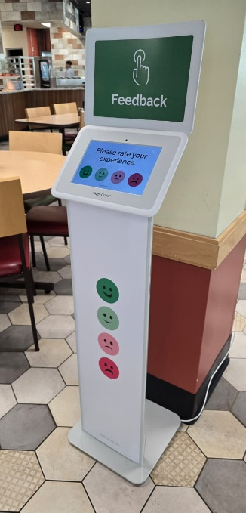 | 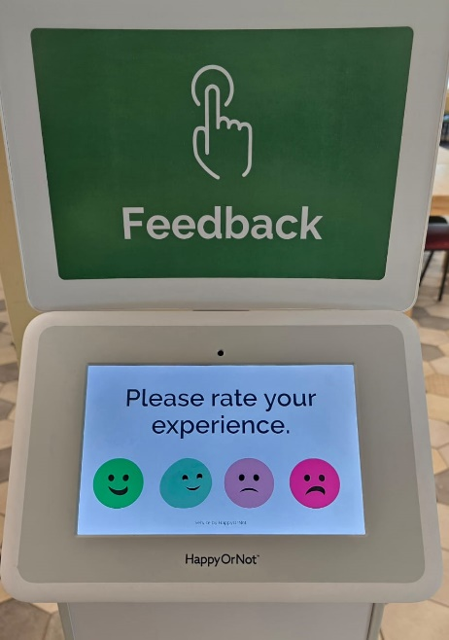
The pictures above show the Happy Or Not survey station in the King’s Dining Hall. There is one at Connerton’s and Susquehanna as well, to monitor student feedback.

