Ayesha Khan
ND 615- Community Nutrition Supervised Experiential Learning
08/19/24

Competency 2.2
Selects, develops and/or implements nutritional screening tools for individuals, groups or populations. (D)
Activity
This competency was met by conducting a needs assessment of the East population of Buffalo, via conducting interviews, for the sole purpose of creating a nutrition education program for addressing these concerns
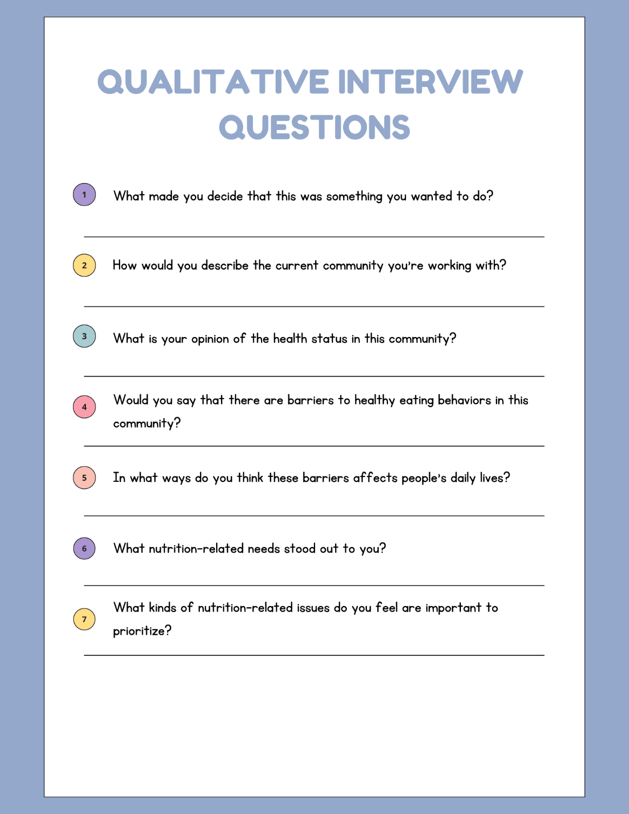
The picture above is a collection of the qualitative interview questions I asked my stakeholder to assess the nutritional needs of the population of Buffalo. I used the response of the interview to figure out the nutrition-related issues to prioritize.

Reflection
Prior to planning this community nutrition education lesson, I didn’t have any experience in conducting qualitative interviews that involved face-to-face, verbal communication. Hence, I was a little apprehensive as to whether it would go smoothly. The most knowledge I had in needs assessment was handing out questionnaires for participants to fill out during my undergrad thesis or conducting the Nutrition Assessment of the Nutrition Care Process on patient case studies.
To better equip myself with how to conduct a qualitative interview, I looked up various examples. They helped me understand the importance of exploring the questions I intended to ask my interviewee and probing for more information where possible, while trying to stay on topic. I also learned how to transition smoothly between topics and improvise my questions where needed. This is one area I’m working on, as conducting an interview comes under counseling, and my communication and self-confidence in being able to speak need to improve.
When I started the interview with the CEO of Buffalo Go Green, I was worried it wouldn’t go that well. But after she explained more about her work and the community she serves; I was able to naturally ask the remaining questions. While I didn’t use any probing techniques, I did ask a couple of closed-ended questions, that weren’t on my list, for definite answers. She discussed the nutrition-related barriers of the community and the needs that should be prioritized in order to improve the situation of the community.
Assessing the needs of the community you’re working in is incredibly important. If you don’t know the nutritional and health-related problems they are facing and what to prioritize, then planning and implementing an intervention will be difficult to figure out. By conducting this assessment for the nutrition education program, I was able to gain a better understanding of the East Side of Buffalo; the nutrition and health-related barriers they are currently facing, the nutritional needs that stand out and need to be addressed, and whether there have been any improvements in the last few years or not etc. Learning about the needs of a particular community this way was eye-opening!

