Ayesha Khan
ND 615- Community Nutrition Supervised Experiential Learning
08/21/24

Competency 6.3
Applies current research and evidence- informed practice to services. (D)
Activity
This competency was met by creating evidence-based lesson plans for the BlueFund project. PowerPoint lessons were created on several nutrition-related topics, using peer reviewed articles.
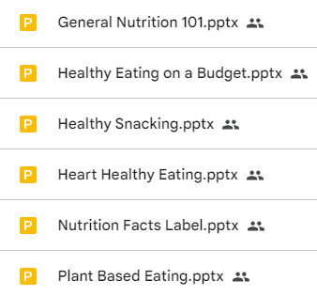  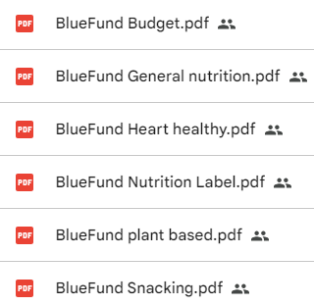 | 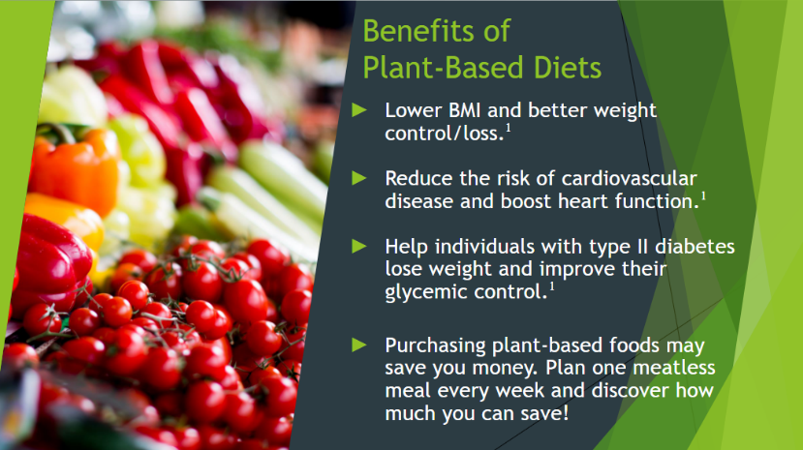  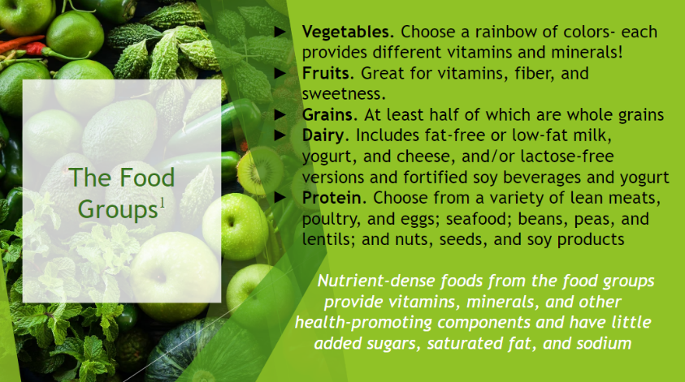  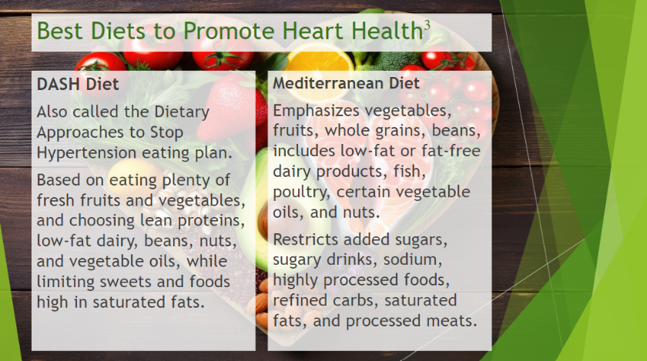  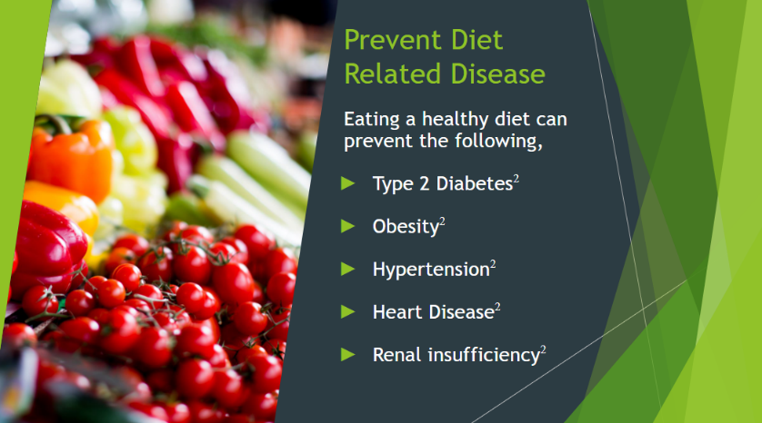
The pictures on the left show the number of PowerPoint Lessons I created for my preceptor and the handouts in PDF form. The photos on the right are some slides I took from these PowerPoint Lessons to give an idea of what is in each of them.

Reflection
My preceptor had asked me to help her in creating several short PowerPoint lessons for an upcoming event they’ll be having, where she will present them. Initially I was supposed to present them, but the date of the event got pushed forward and I wasn’t working with them long enough to take part, which was unfortunate. Still, I did my best to find evidence-based information for each topic my preceptor shared with me. She also gave me some material to work with for each PowerPoint presentation.
The information was basic as it was for the general population. When creating these lessons, I realized that it’s slightly difficult for me to word things in a way that can be easily understood. That was something my preceptor pointed out as well. She also mentioned that I tend to write a bit too much in some of the slides and need to cut down on information in some areas. I have a better sense of this stuff now, ever since working on these nutrition presentations. I learned to simplify my words and phrases better and remove unnecessary information.
Current research is important to reference, as it gives credibility to the material you are presenting. People will also tend to believe the content that is being delivered to them if they know that authentic references have been used to validate the claims that are being made. I started regularly using peer-reviewed articles back in undergrad for my assignments, since it became compulsory. Ever since then, I’ve learned to look for evidence-based research for any topic I have an assignment or project on.

