Ayesha Khan
ND 616 – Food Systems or Service Supervised Experiential Learning
Competency 6.3
Applies current research and evidence- informed practice to services. (D)
Activity
This competency was met by giving out educational handouts on Omega-3 fatty acids and talking about how good they are for heart health.
Reflection
King’s Dining was in charge of doing a station hosting for the Feel-Good Foods event at King’s Court. Nicole and I were in charge of serving heart-healthy food to students who stopped by, giving handouts on Omega-3s and talking about why they’re good for health.
I’ve never served at a kitchen line before, so it was interesting to watch Nicole serving food and interacting with students. I learned a lot just by observing and also helped serve food to a few students, although I was mainly in charge of giving the Omega-3 handouts and talking about the benefits of consuming them.
The food we were serving was a bowl of honey-glazed salmon, turmeric wild rice, Korean cucumbers, sweet chili sauce, and different toppings. We ended up getting a lot of positive feedback on the salmon rice bowl, which was pleasantly surprising. We also asked some students if they knew the benefits of Omega-3 fatty acids and a couple did know, which was cool.

Pictures can be viewed below!

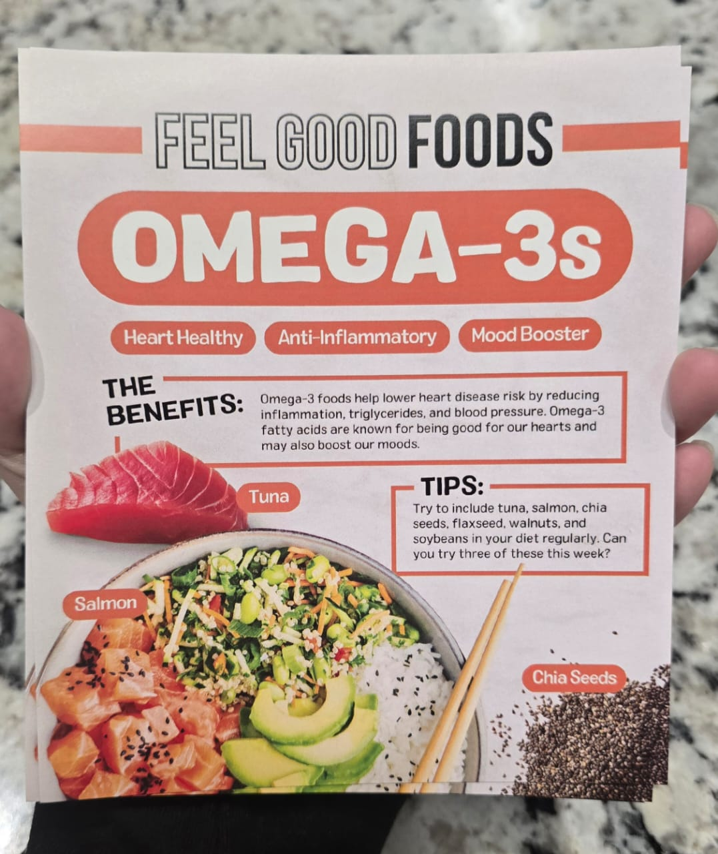

The picture above shows the Omega-3 handouts that I gave to students who came to our kitchen line for the salmon rice bowl.

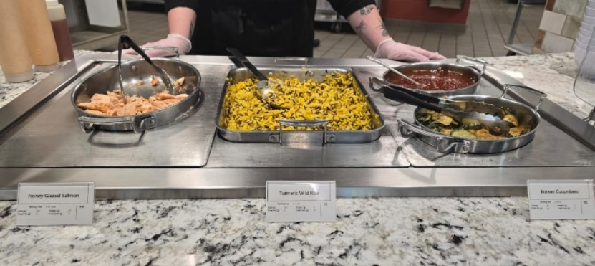 | 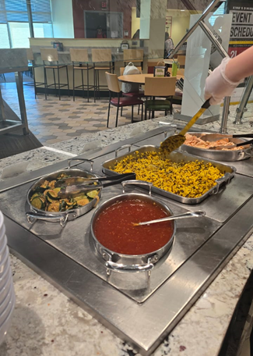
The pictures above show the heart healthy food we were serving for the day. It was a bowl with honey-glazed salmon, turmeric wild rice, Korean pickles, sweet chili sauce, and different toppings the students could put on their food.

