Ayesha Khan
ND 616 – Food Systems or Service Supervised Experiential Learning
Competency 3.2
Oversees the purchasing, receipt and storage of products used in food production and services (D)
Activity
This competency was met by watching my preceptor place an order and seeing how the order was received and stored.
Reflection
It was interesting listening to Jeff explain the entire process of placing an order, receiving it, making sure the ordered products pass the temp checks and then safely storing it until needed. He mentioned that Monday, Wednesday, and Friday are the ordering days, where either he or David Gill, the executive chef, put in orders to be either delivered to the King’s Dining facility or Susquehanna. Every Friday Asian Chefs at Susquehanna order for the week, which gets delivered to them directly on Monday.
Jeff had orders to place for Susquehanna, which I was able to observe. He showed me the MyOrders website, which looked pretty confusing at a first glance. The website has all the units present on campus and Jeff mentioned that they use SYSCO as the main purveyor when placing orders. He then entered the required items and placed the order, which would be directly delivered to Susquehanna. Surprisingly, the entire process ended up being much easier than I initially thought.
While I wasn’t able to witness the Susquehanna order being received and stored, since it gets delivered to them directly, I was able to see an order received for Connerton’s, which is another unit on campus, as they get delivered to the King’s Dining facility, where I work. The products were placed on a cart and sent to the kitchen, where temperature checks were done. They were also checked for other kinds of abuse, like cans checked for dents, before being safely placed into the walk-in coolers for storage. I definitely learned a lot from observing this process. It was interesting to see yet another side of food service.

Pictures can be viewed below!

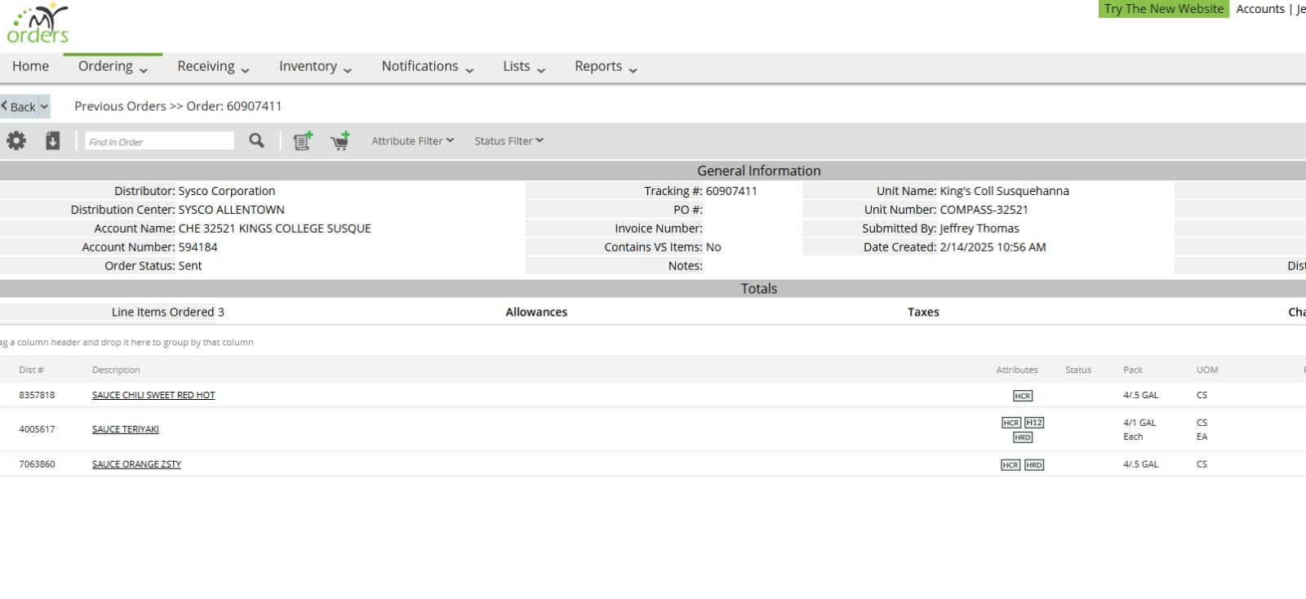

This picture shows the MyOrder website that King’s Dining uses to place orders for different items when they are required. The above is an example of items being ordered for Susquehanna
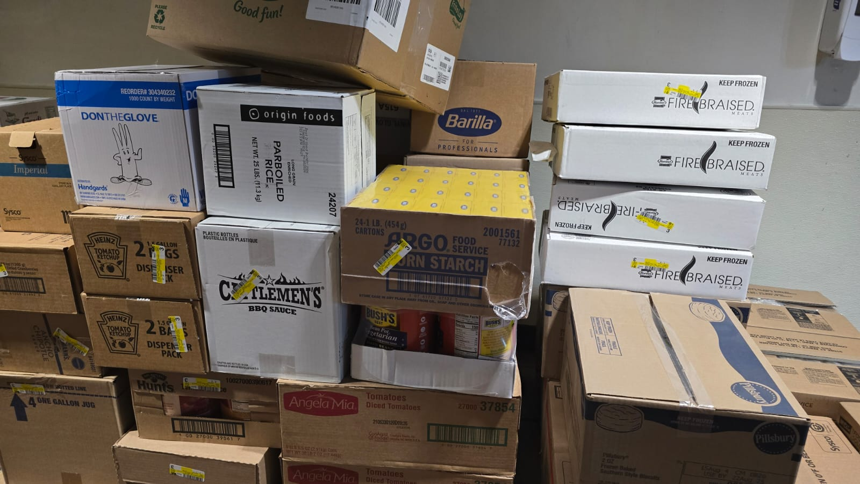

This picture shows the ordered items being delivered by SYSCO, which will then be taken to the kitchen for temp checks before being stored.
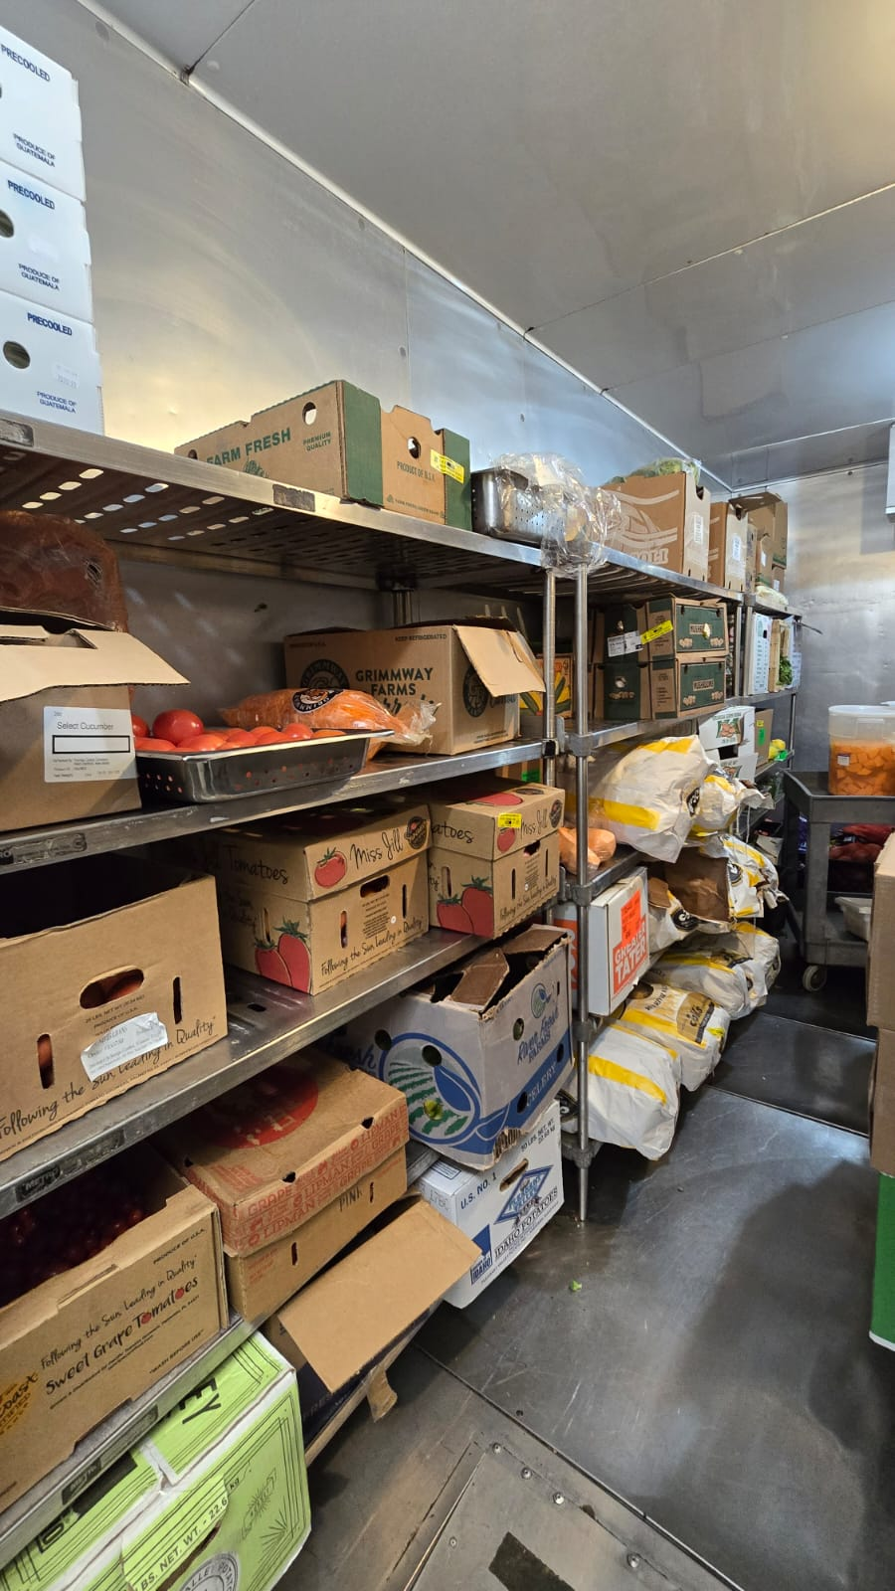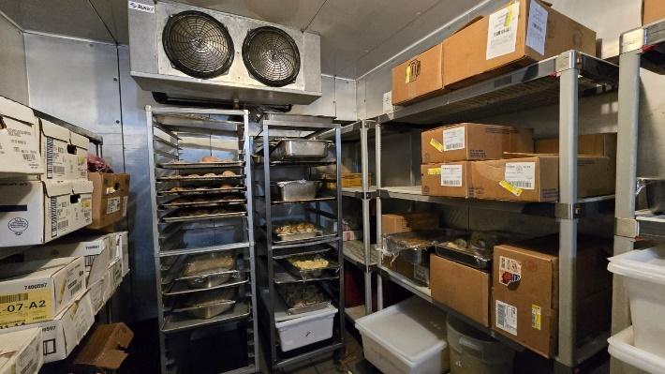

This picture shows produce and other items being stored in walk-in coolers until they are needed. The temperature of the coolers is maintained to avoid temperature abuse.

