Ayesha Khan
ND 616 – Food Systems or Service Supervised Experiential Learning
Competency 3.1
Directs the production and distribution of quantity and quality food products (D)
Activity
This competency was met by conducting a kitchen inspection at King’s Court.
Reflection
The step-wise process of conducting a kitchen inspection was intriguing. I went around with Jeff and we inspected the walk-in coolers and freezers. I’ve never conducted a kitchen inspection, so it was an interesting experience. I also realized, throughout this inspection, that there’s a lot of areas where contamination can occur, so proper monitoring is crucial to maintain food safety.
When we checked the walk-in coolers, they were at the recommended temperature i.e., ≤ 41ºF. A couple of coolers had the thermometers near the door, so Jeff told one of the staff members to move them further into the coolers. This is because the door continuously opens and closes, which can cause fluctuations in the temperature near the door. This will result in an inaccurate reading of the overall temperature in the cooler.
We inspected the TCS food stored in the coolers; whether or not they were at the correct temperature and stored at the appropriate height above the ground. We also inspected the temperature logs that were outside each cooler, to make sure that someone was logging them properly. Jeff and I checked that no employee personal items, beverages or food were present in the walk-in coolers/freezers.
After conducting the inspection, we filled out the checklist. The entire process was pretty quick, and the inspection checklist was also to-the-point. I was curious as to how frequently the temperature logs were entered, and David Gill, the Executive Chef, mentioned that one of the staff members usually does it twice a day, once in the morning and once in the afternoon/evening. He also showed me the ring binder they have, in which they have stored the logs for all their temperature checks over the years.
Jeff showed me the different checklists he has for different sections of the kitchen, like inventory, equipment, food preparation areas etc. He mentioned that that he’s required to do these checks quarterly, but he usually does them every month.

Pictures can be viewed below!

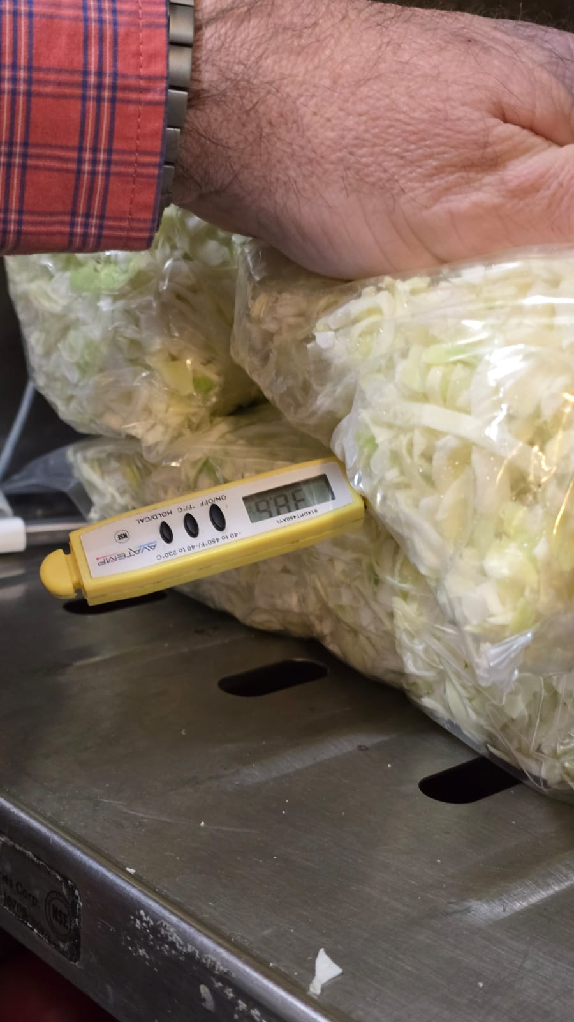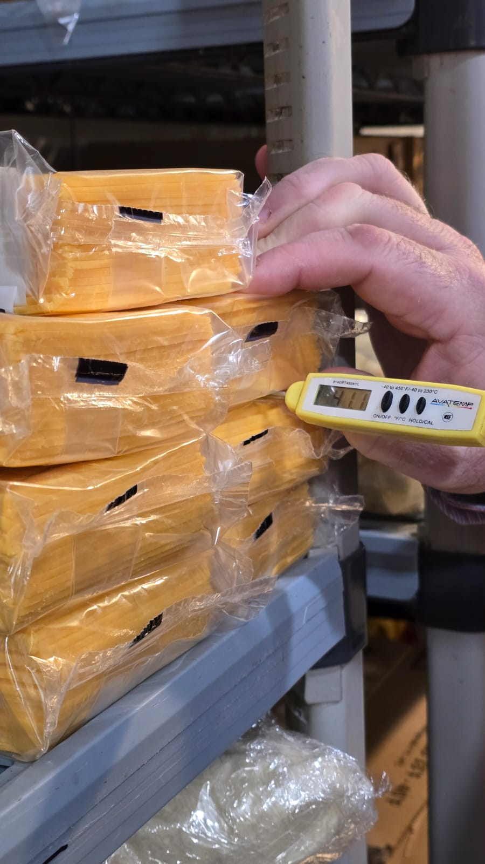

The pictures above show my preceptor checking the temperature of TCS food in the walk-in cooler. The lettuce and cheese were below 41ºF (I ended up taking the cheese picture slightly early, which is why it is slightly above 41ºF).
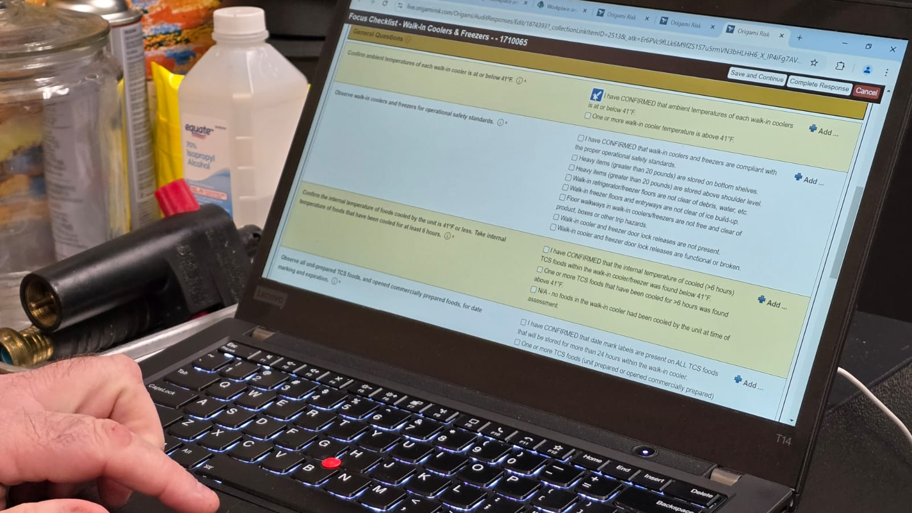

The picture above shows my preceptor and I filling out the checklist for the Coolers & Freezers after conducting the inspection.

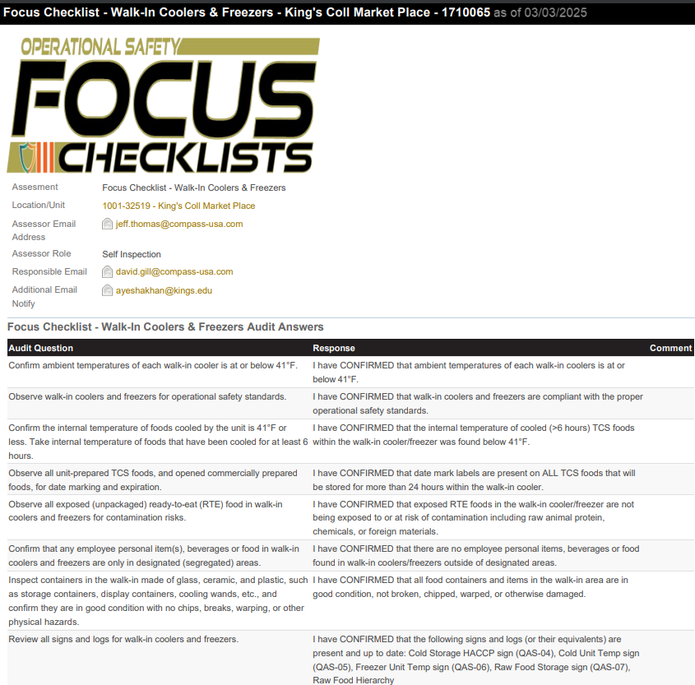

The picture above is the Focus Checklist Audit Answers for the Walk-In Coolers & Freezers inspection that we conducted.

