Ayesha Khan
ND 615- Community Nutrition Supervised Experiential Learning
07/25/24

Competency 1.3
Applies knowledge of microbiology and food safety. (S)
Activity
This competency was met by using my knowledge of food safety. I first sanitized my hands and then wore gloves to handle the produce that we would be taking to the farmer’s market. I separated the spoiled produce from the unspoiled produce and put the rest of the produce we wouldn’t be taking with us in the CoolBot. I learned how the technology of the CoolBot works to control the air conditioner and keep the produce under the desired temperature.
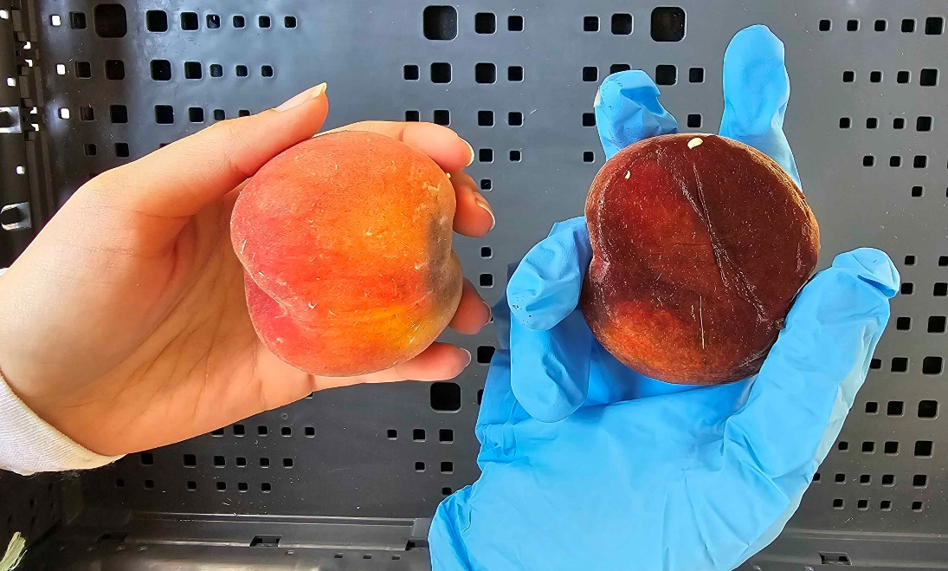
The picture above shows two peaches, each of differing quality. The peach on the left can be sold at the farmer’s market, while the peach on the right is spoiled and cannot be sold.

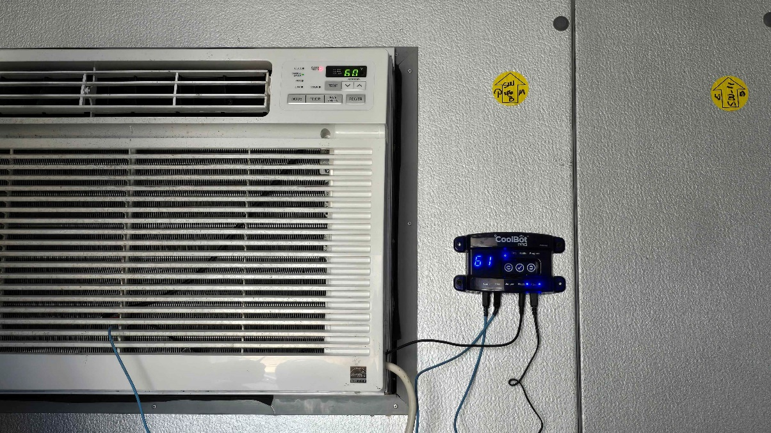
This is a picture of the CoolBot temperature controller (on the right) that directs the air conditioner (on the left) to operate in a way to cool the room to 36 °F without ever freezing up. A traditional A/C can’t go below 60 °F because it’s electronically limited but with this micro-controller, that’s no longer an issue.

Reflection
Handling of produce and sanitation were a consistent part of my community SEL work. My main duties were bagging and boxing of produce we’d be taking to different Markets, selling the produce to customers, and then cleaning up everything afterwards. One of the first things I learned was the importance of recognizing spoiled produce and separating it from the produce we’d be selling. I took care to put cooling pads under the vegetables that could get spoiled from the heat of the sun, since the markets would run for a minimum of 3 hours and a maximum of 5 hours and they would be in the sunlight for a while. I did try to keep some of the vulnerable produce (herbs and leafy greens) on shelves that were out of the sun’s rays.
I also learned how the CoolBot works on the second day of my community SEL. It was fascinating to learn how it regulates the temperature inside so that the air conditioner doesn’t freeze up, since traditional A/Cs can’t go below 60 °F because they are electronically limited. The harvested produce is stored in the CoolBot and is taken out during market days to be sold to the underserved population of Buffalo.
I really enjoyed this aspect of my work, as working with food is something that interests me. I hadn’t even heard of some of the produce that’s being grown on the farms of Buffalo Go Green, like cue ball zucchini, swiss chard, and collard greens. While interacting with customers isn’t a strong suit of mine, this work is slowly helping me improve on that skillset as well.

