Ayesha Khan
ND 616 – Food Systems or Service Supervised Experiential Learning
Competency 1.12
Demonstrates knowledge of and is able to manage food preparation techniques (D)
Activity
This competency was met by building a recipe for patients with Crohn’s Disease and scaling it to yield 30 servings
Reflection
Throughout my Masters’s program, I did a couple of projects that required me to create recipe cards. Whenever I’d look up particular recipes, like broccoli rice, most websites would almost always have a scale which could be used if we wanted to adjust the recipe for more than one serving. Although, these recipe scales were pretty limited. Hence, I was aware of recipe scaling when starting my Food Service SEL.
When I created a recipe using Webtrition, I was amazed that recipes could scale to whatever amount we wanted, be it 50, 100 or even beyond that. It was also a little overwhelming navigating the website, but Jeff, the King’s Food Service Director, explained how it works and it was surprisingly very easy and convenient. One thing I really liked was the sub-recipes for each ingredient when making a recipe. For example, I picked a recipe to build keeping patients with Crohn’s Disease in mind and it was incredible how there were sub-recipes for each ingredient. The recipe I selected was vegetable fried rice with shrimp.

Pictures can be viewed below!

HC Vegetable Fried Rice (Shrimp)
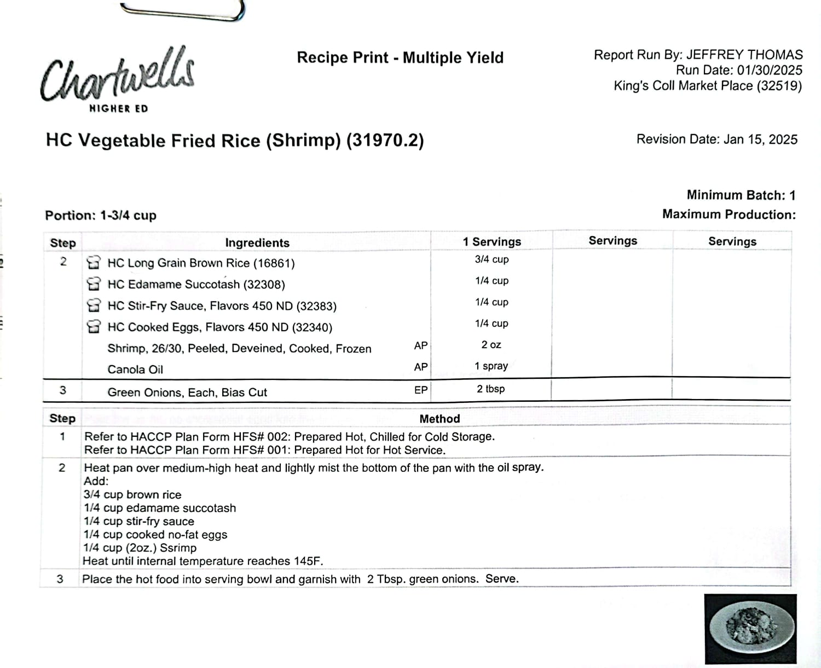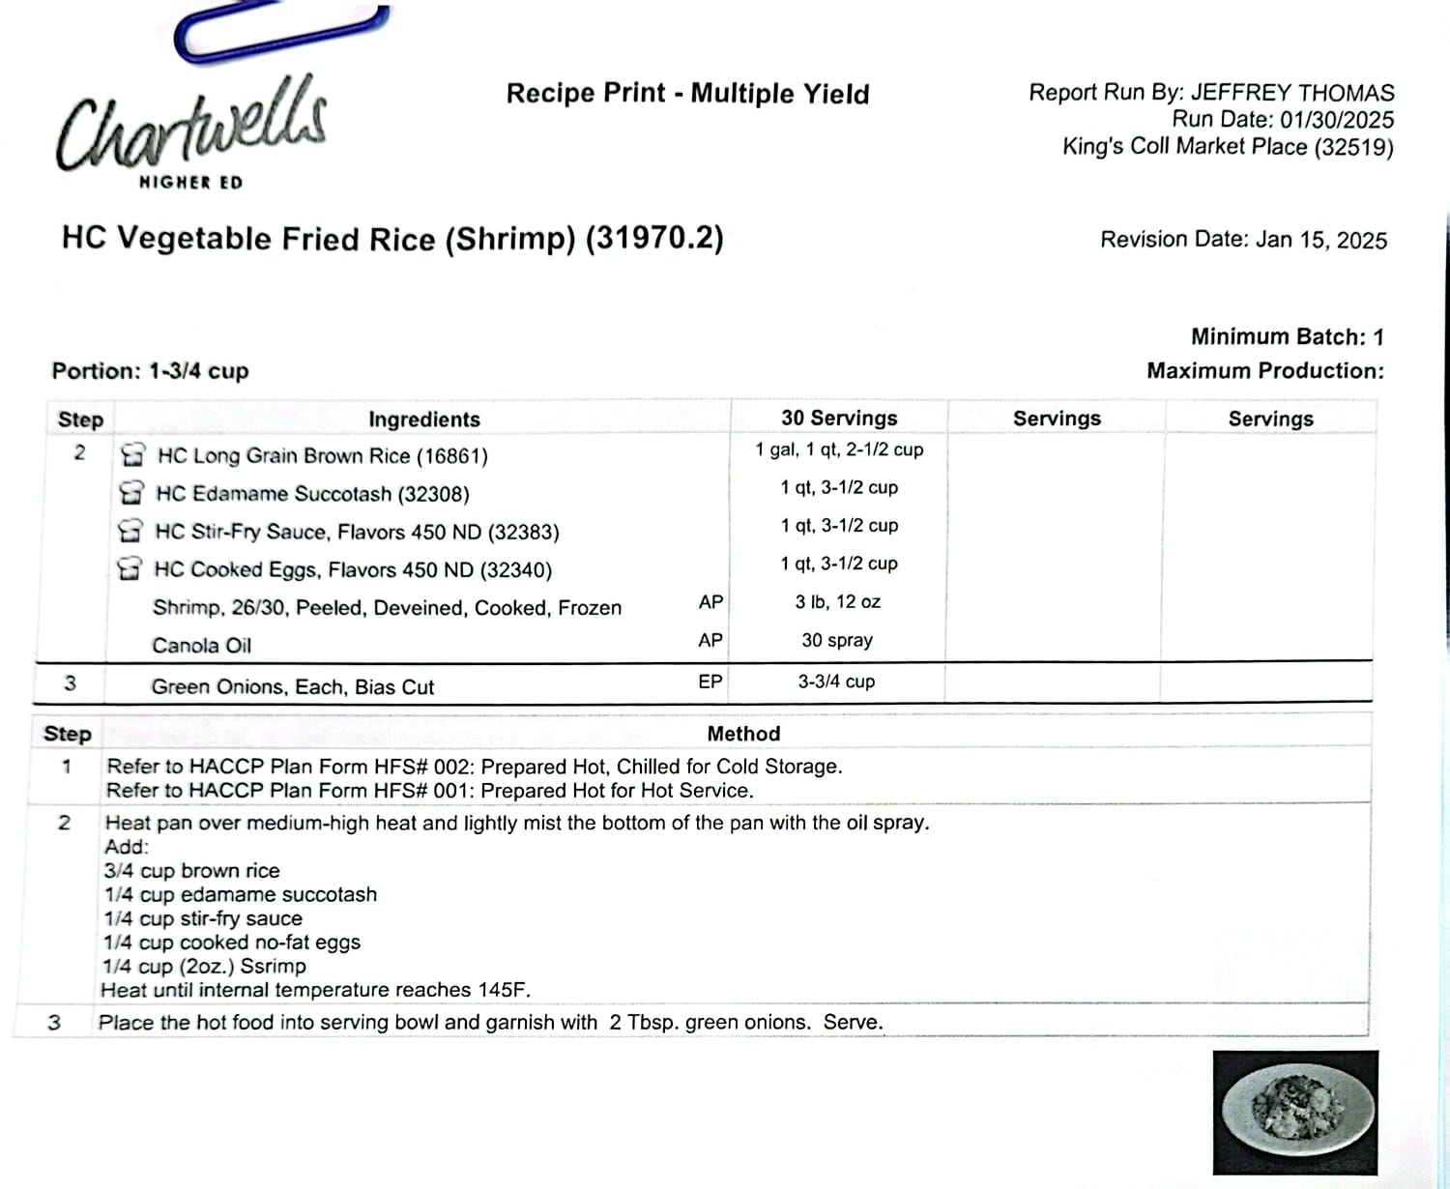

The picture on top shows the recipe portions for 1 serving, while the picture below shows the recipe portions scaled for 30 servings

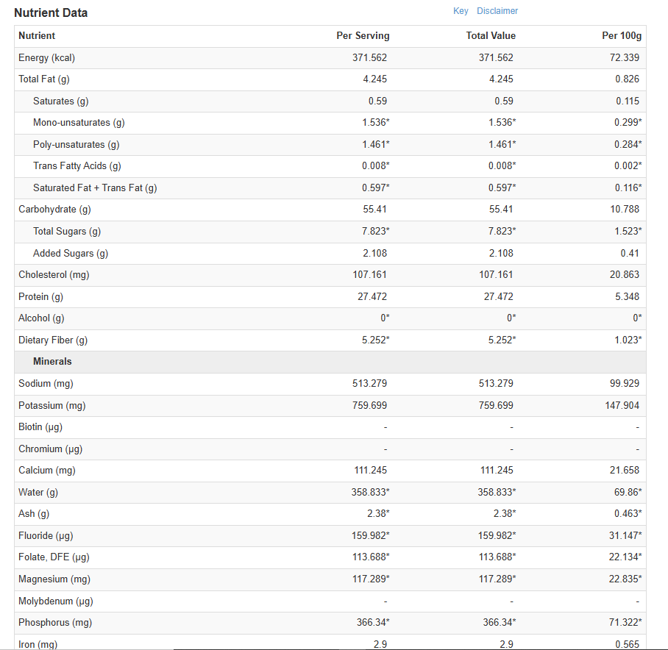

The picture above shows the nutritional data per serving of the recipe

