Ayesha Khan
ND 615- Community Nutrition Supervised Experiential Learning
08/19/24

Competency 2.3
Utilizes the nutrition care process with individuals, groups or populations in a variety of practice settings. (D)
Activity
This competency was met by delivering nutrition education at a health fair, by first assessing the needs of the population (competency 2.2). As the place where I was doing my SEL is very protective of their population, I wasn’t able to apply the Nutrition Care Process properly, which I hope to do during my Clinical SEL, where the intervention will be more client-focused.
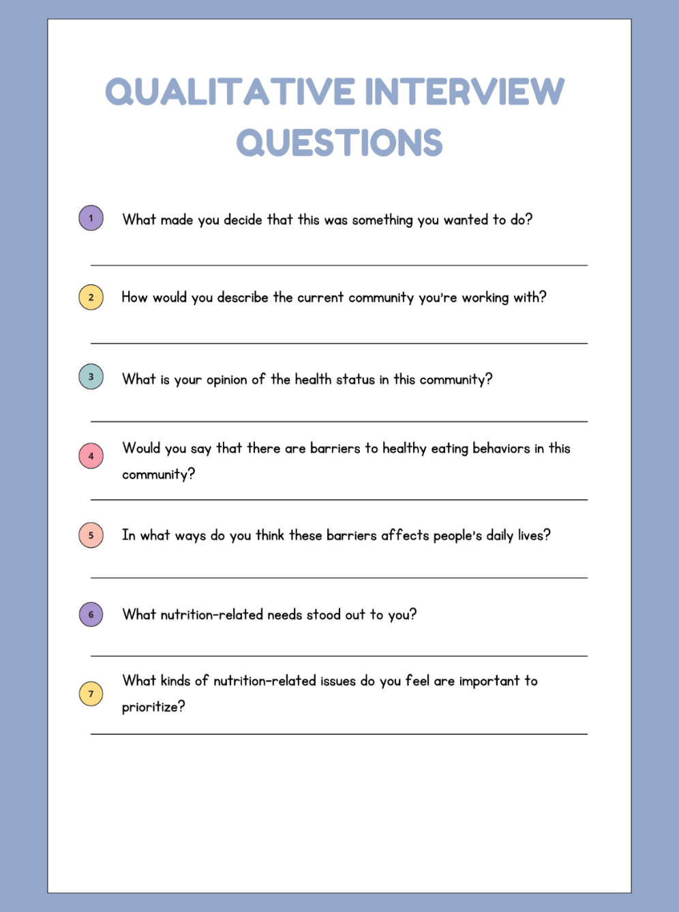 | 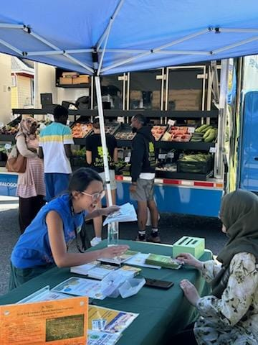  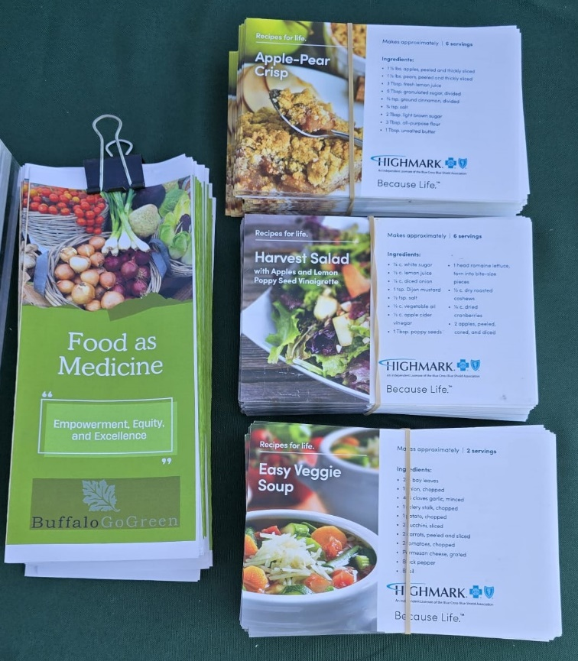
The picture on the left was a collection of qualitative interview questions that I asked my stakeholder to assess the needs of the population. After identifying the nutritional needs to prioritize, I created easy-to-make, low-budget recipe cards and brochure on the concept of Food as Medicine.

Reflection
Conducting a Nutrition Care Process on the community where I was doing my SEL wasn’t exactly possible as they are incredibly protective of the people they serve. The closest I got was assessing the needs of the community via stakeholder interviews and providing nutrition information on addressing those needs.
That being said, conducting a needs assessment was very eye-opening, mostly because I have never done a qualitative interview. Face-face communication, particularly if it’s being recorded, makes me feel tense, although that has been gradually improving. Conducting an interview with the CEO of Buffalo Go Green was daunting at first but I gradually got the hang of it and was able to have a smooth conversation regarding the nutritional and health status of the community and the needs that must be addressed.
For the nutrition education lesson, I created easy-to-make, low-budget recipe cards and brochure on the concept of Food as Medicine. During the community event, I talked to a few people about the important health benefits of nutrient-dense produce and how to create easy-to-make recipes from the produce that could be bought at our mobile market. A lot of people were receptive, especially to the recipes. I felt that my communication improved substantially after implementing this nutrition education lesson.

